* Cask Strength Series -

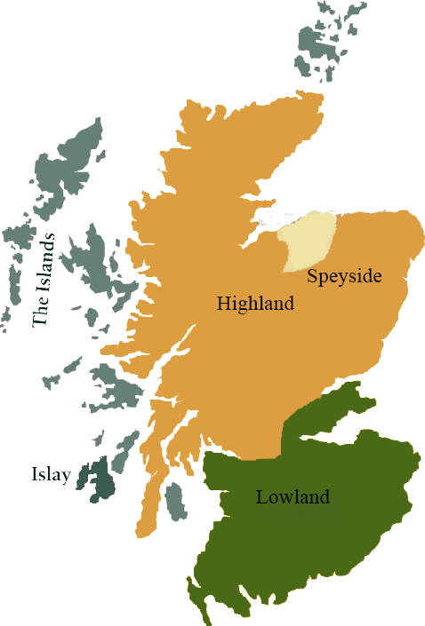*A comprehensive selection of natural strength whiskies, in individually numbered bottles, is available. This selection offers whiskies up to 35 years old, with rare malts being offered in a luxurious gift box with a certificate of authenticity.*

# Ledaig 2004

ISLAY REGION • SHERRY BUTT CASK

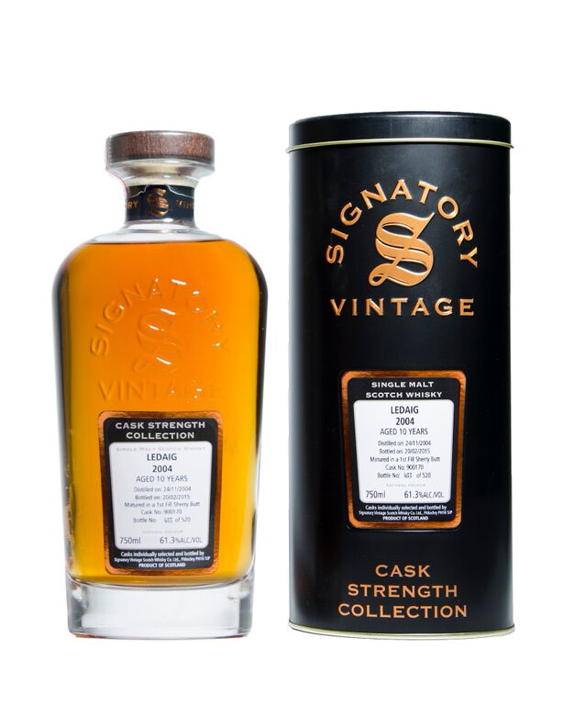

**AGED:** 17 years

**DISTILLED ON:** November 24, 2004

**BOTTLE ON:** February 20, 2015

**MATURED IN:** 1st Fill Sherry Butt

**CASK NO:** 900170

**BOTTLE NO:** of 520

_________________________________________

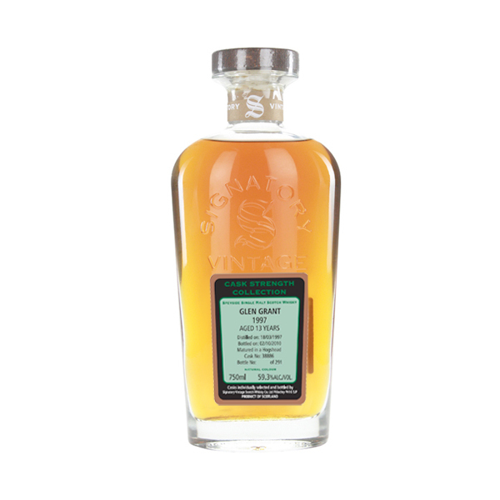

Ledaig scotch comes from the Tobermory distillery, which is proudly one of Scotland’s oldest. Established in 1798, it is the only distillery on Mull. It is unique, not just because of its idyllic location, but because it produces two different, but equally alluring, single malts: the fruity, unpeated Tobermory, and the more robust and smoky Ledaig.

# TASTE NOTES

**COLOR**: dark amber

**NOSE**: Smoke and vanilla. Rich and warm. Some gasoline (in a good way), along with lemon and grapes. Fresh and a bit dry. Complex and keeps changing throughout my sniffing.

**TASTE**: Smoky, rich taste. Mostly vanilla, licorice, lemon and ashes. Not very complex to taste, but powerful!

**FINISH**: White pepper, smoke, ashes and licorice. The sweetness disappears.

www.SignatoryUSA.com

Imported by Total Beverage Solution

C:\STOCKLAYOUTS\CURRENT PROJECTS\FN99807-PL\FN99807-IMG05.emf

www.SignatoryScotch.com

IMPORTED BY TOTAL BEVERAGE SOLUTIONS