* 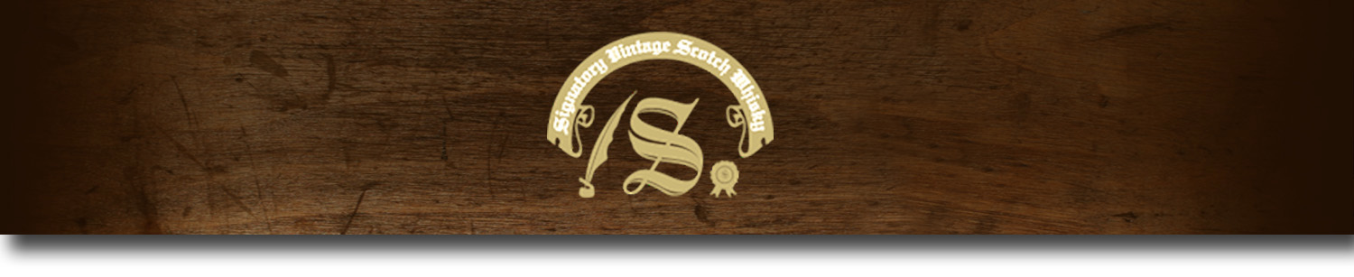Cask Strength Series -

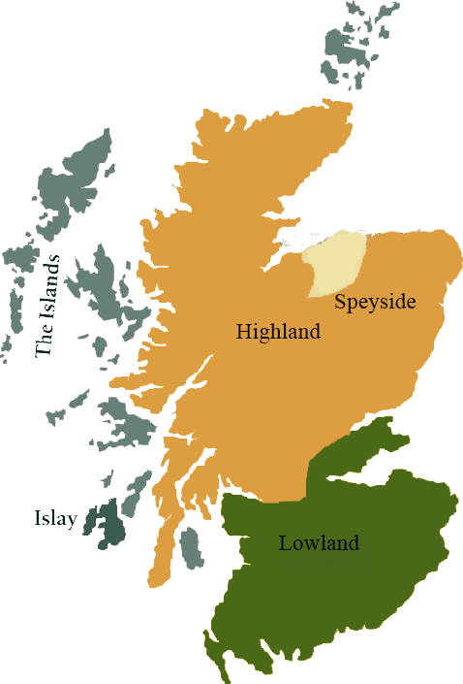*A comprehensive selection of natural strength whiskies, in individually numbered bottles, is available. This selection offers whiskies up to 35 years old, with rare malts being offered in a luxurious gift box with a certificate of authenticity.*

# Laphroaig 1997

ISLAY REGION • HOGSHEAD CASK

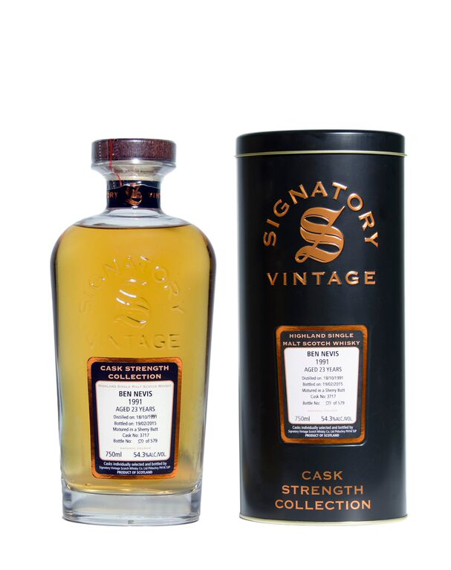

**AGED:** 17 years

**DISTILLED ON:** October 8, 1997

**BOTTLE ON:** March 3, 2015

**MATURED IN:** Hogshead

**CASK NO:** 8367

**BOTTLE NO:** of 223

_________________________________________

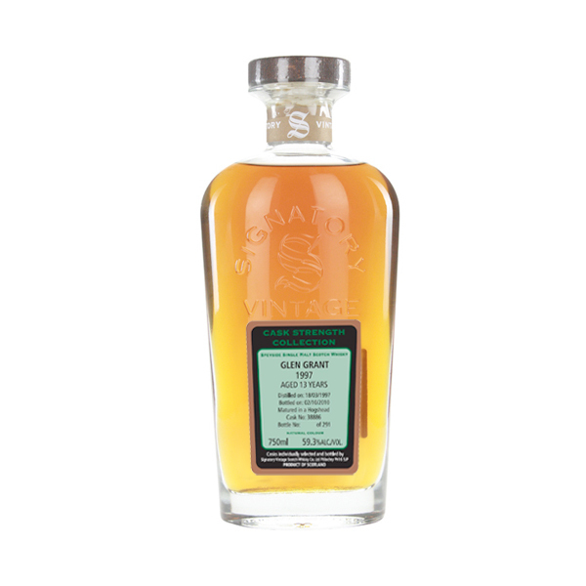

Named after the Isle of Islay's Loch Laphroaig, this single malt whiskey distillery has been operating since its establishment in 1815. Home of the only whiskey to carry the Royal Warrant of the Prince of Wales, this esteemed distillery uses traditional methods to create it's distinct malt.

# TASTE NOTES

**COLOR**:

**NOSE**: peaty, but not overwhelmingly so.

**TASTE**: slick and oily, full of restrained sweet notes, seaweed, iodine, and salt. Medicinal, especially in the finish, but with charming floral notes.

**FINISH**: peat, oak casks, cork, and iodine remain, with a dry salty feeling to the mouth.

www.SignatoryUSA.com

Imported by Total Beverage Solution

C:\STOCKLAYOUTS\CURRENT PROJECTS\FN99807-PL\FN99807-IMG05.emf

www.SignatoryScotch.com

IMPORTED BY TOTAL BEVERAGE SOLUTIONS