* 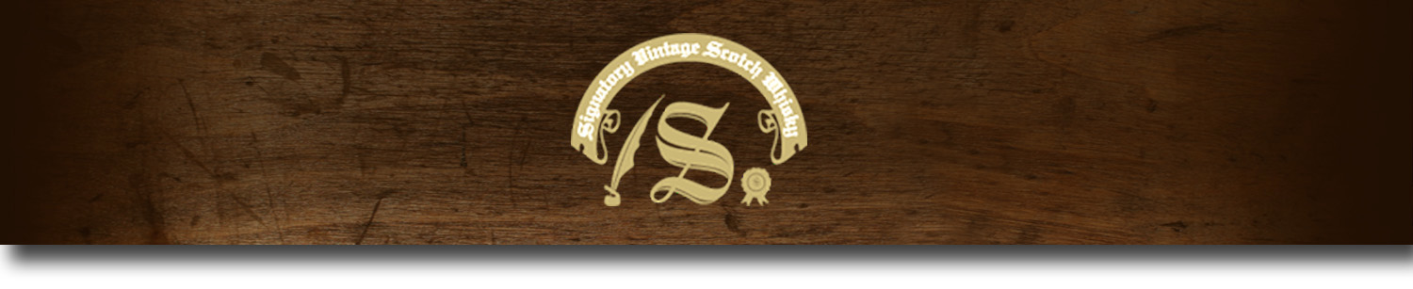Un-Chillfiltered Series -

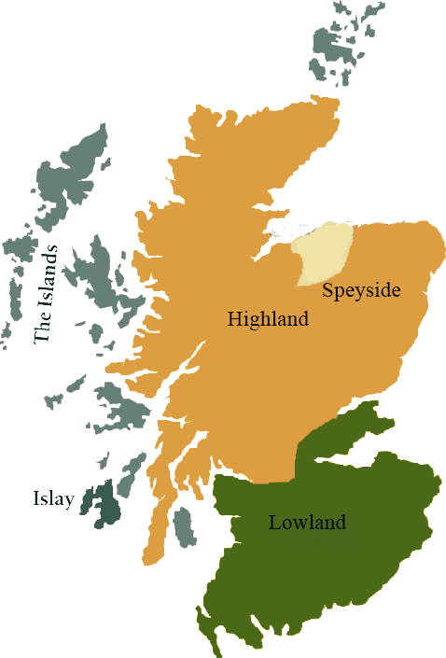*A comprehensive selection of natural strength whiskies, in individually numbered bottles, is available. This selection offers whiskies up to 35 years old, with rare malts being offered in a luxurious gift box with a certificate of authenticity.*

# Highland Park 1999

ISLAND REGION • BOURBON BARREL

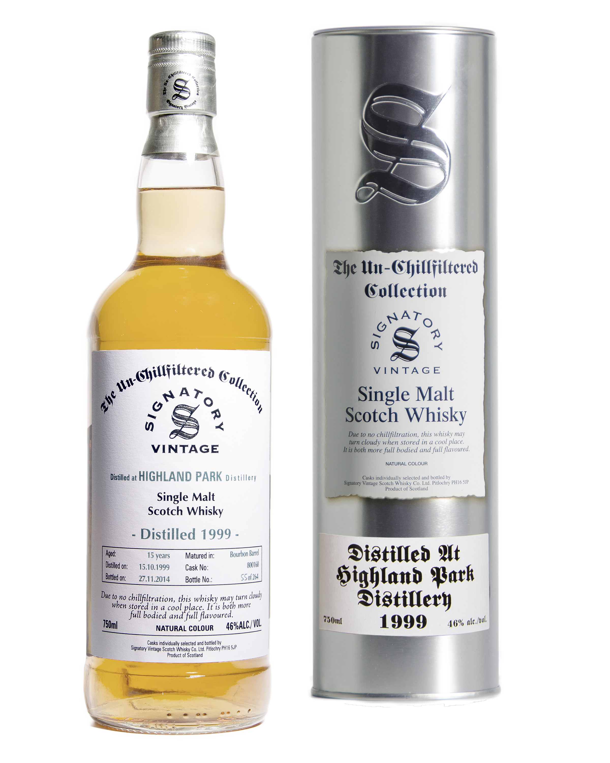

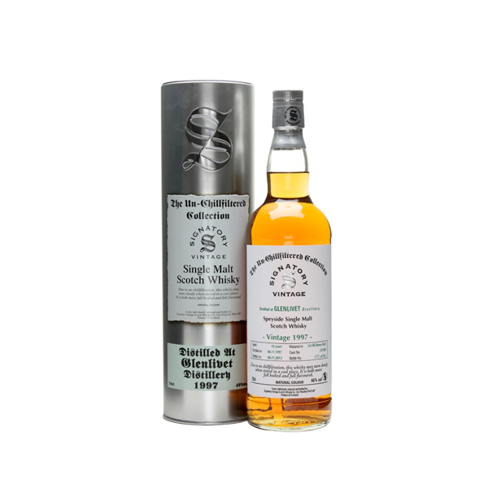

**AGED:** 15 years

**DISTILLED ON:** October 15, 1999

**BOTTLE ON:** November 27, 2014

**MATURED IN:** Bourbon Barrel

**CASK NO:** 800168

**BOTTLE NO:** of 264

_________________________________________

Established in 1798, Highland Park is one of the most remote Scotch whisky distilleries in the world. Located on in the Orkney islands, the distillery has been producing premiere malts for over 200 years. Its unique location allows Highland Park to produce spirits of unparalleled taste and quality.

# TASTE NOTES

**COLOR**: golden wheat

**NOSE**: Sweet stewed apple, fruity gummi chews, pear drops, rhubarb and custard sweets, porridge (with dark demerara sugar) and hints of furniture polish.

**TASTE**: Softer than expected to start, with cream and gentle ground cinnamon spiciness. Fruit rolls in behind that, with raisins and apple joined by cinnamon bark and soft flapjacks. There's an elegant mustiness hiding behind the fruit, like an old cupboard, with hints of flamed orange zest appearing right at the end.

**FINISH**: Gentle cinnamon and nutmeg spiced porridge, with sweet grass and hay notes growing as it fades.

C:\STOCKLAYOUTS\CURRENT PROJECTS\FN99807-PL\FN99807-IMG05.emf

Imported by Total Beverage Solution

www.SignatoryUSA.com

www.SignatoryScotch.com

IMPORTED BY TOTAL BEVERAGE SOLUTIONS