* 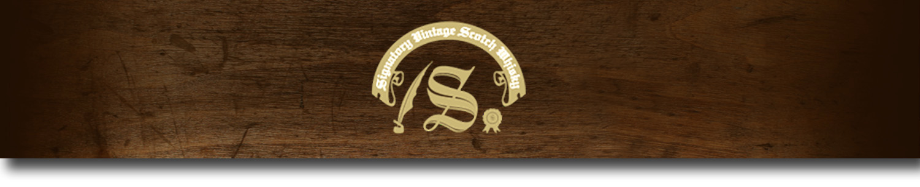Un-Chillfiltered Series -

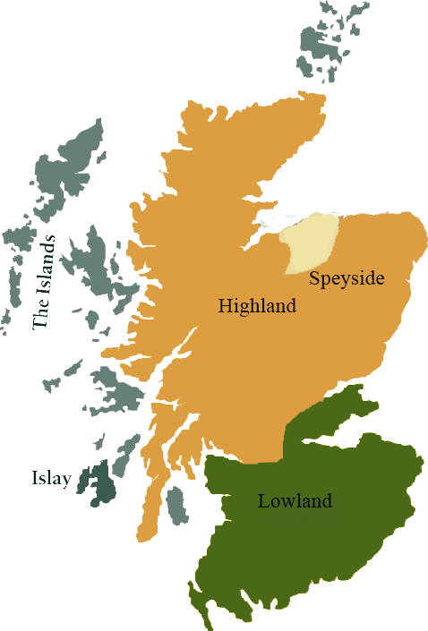*A comprehensive selection of natural strength whiskies, in individually numbered bottles, is available. This selection offers whiskies up to 35 years old, with rare malts being offered in a luxurious gift box with a certificate of authenticity.*

# Dufftown 1997

SPEYSIDE REGION • HOGSHEAD CASK

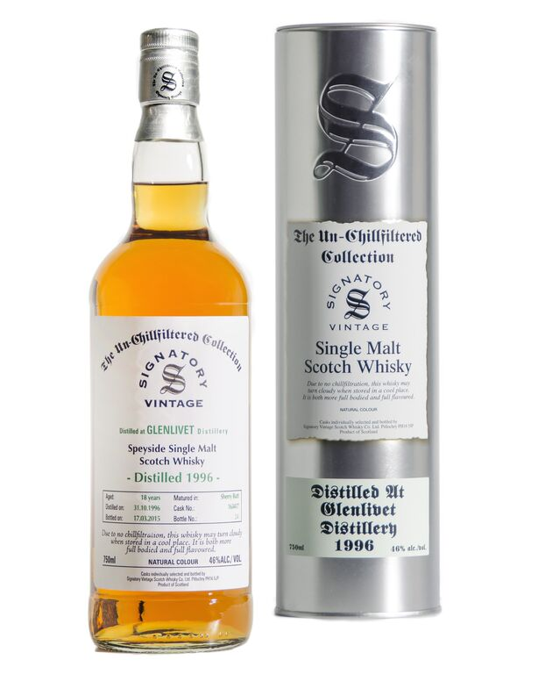

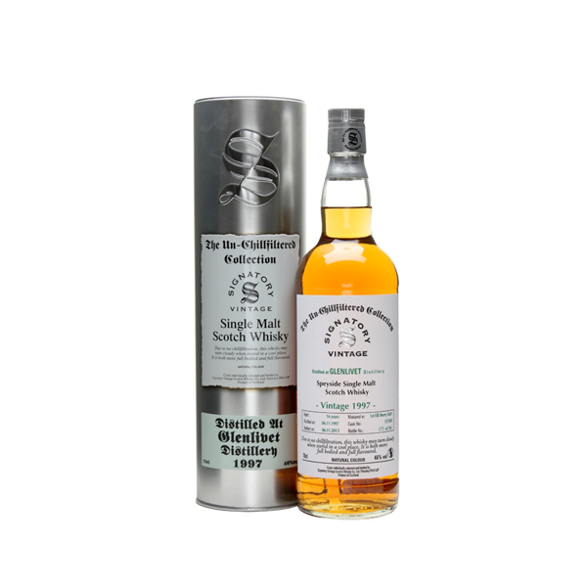

**AGED:** 16 years

**DISTILLED ON:** December 9, 1997

**BOTTLE ON:** October 14, 2014

**MATURED IN:** Hogshead

**CASK NO:** 19493

**BOTTLE NO:** of 378

_________________________________________

Founded as "Dufftown-Glenlivet Distillery," this Speyside distillery is currently owned by Diageo. Once used as a mill, the building was converted in 1896, and today the distillery operates six stills and has a capacity of 4,000,000 litres per year.

# TASTE NOTES

**COLOR**: Amber

**NOSE**: Slightly spicy and drying, overall. Toffee apples and hints of honeycomb. Becomes fruitier: ripe autumn fruits combined with red berry sharpness. Some golden syrup sweetness. Reassuringly well balanced. Adding water brings up a waxier note initially, with traces of sweet chestnut and and then a whiff of smoke or charred wood.

**TASTE**: Without water, the flavor is sweet to start then drying in the finish. Warming, light and smooth; tending to delicate. Fresh fruit with spicy top notes.

**FINISH**: Drying. Pears and digestive biscuits, then delicately spiced with notes of cinnamon.

C:\STOCKLAYOUTS\CURRENT PROJECTS\FN99807-PL\FN99807-IMG05.emf

Imported by Total Beverage Solution

www.SignatoryUSA.com

www.SignatoryScotch.com

IMPORTED BY TOTAL BEVERAGE SOLUTIONS