* Un-Chillfiltered Series -

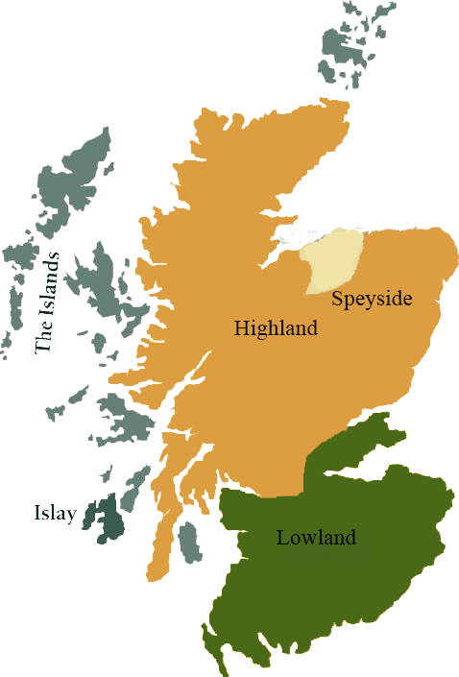*A comprehensive selection of natural strength whiskies, in individually numbered bottles, is available. This selection offers whiskies up to 35 years old, with rare malts being offered in a luxurious gift box with a certificate of authenticity.*

# Laphroaig 1998

ISLAY REGION • REFILL SHERRY BUTT

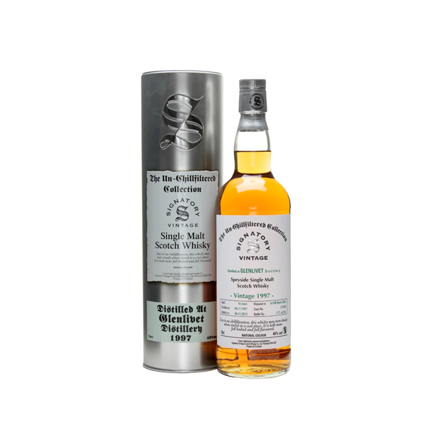

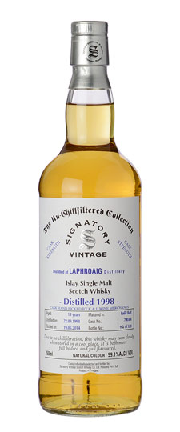

**AGED:** 16 years

**DISTILLED ON:** September 22, 1998

**BOTTLE ON:** October 14, 2014

**MATURED IN:** Refill Sherry Butt

**CASK NO:** 700388

**BOTTLE NO:** of 739

_________________________________________

Named after the Isle of Islay's Loch Laphroaig, this single malt whiskey distillery has been operating since its establishment in 1815. Home of the only whiskey to carry the Royal Warrant of the Prince of Wales, this esteemed distillery uses traditional methods to create it's distinct malt.

# TASTE NOTES

**COLOR**: dark amber

**NOSE**: big, very, very concentrated, and redolent of iodine, sweet spices, good, mature sherry and creamy vanilla.

**TASTE**: very thick and rich, a massive mouthful of malt and sherry with good fruity sweetness, powerful peat and oak.

**FINISH**: long, spicy finish, figs, dates, peat smoke, vanilla

C:\STOCKLAYOUTS\CURRENT PROJECTS\FN99807-PL\FN99807-IMG05.emf

Imported by Total Beverage Solution

www.SignatoryUSA.com

www.SignatoryScotch.com

IMPORTED BY TOTAL BEVERAGE SOLUTIONS