* 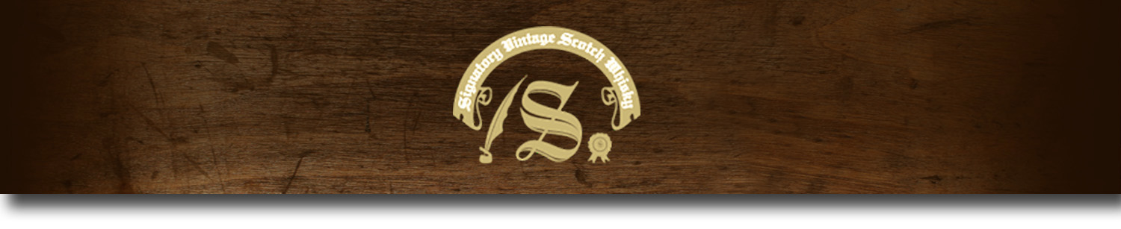Un-Chillfiltered Series -

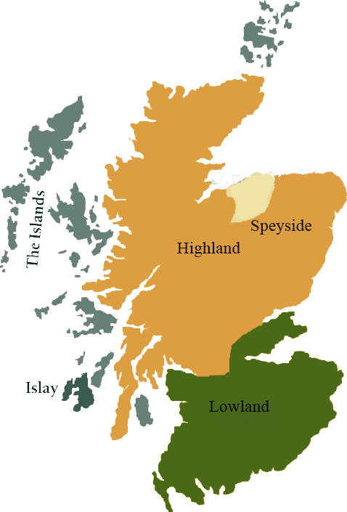*A comprehensive selection of natural strength whiskies, in individually numbered bottles, is available. This selection offers whiskies up to 35 years old, with rare malts being offered in a luxurious gift box with a certificate of authenticity.*

# Caol Ila 1995

ISLAY REGION • HOGSHEAD

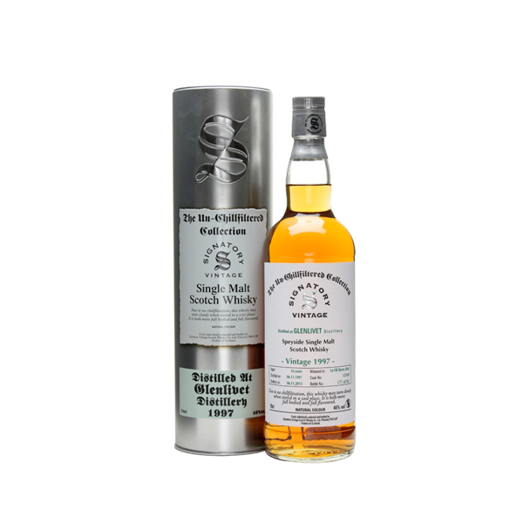

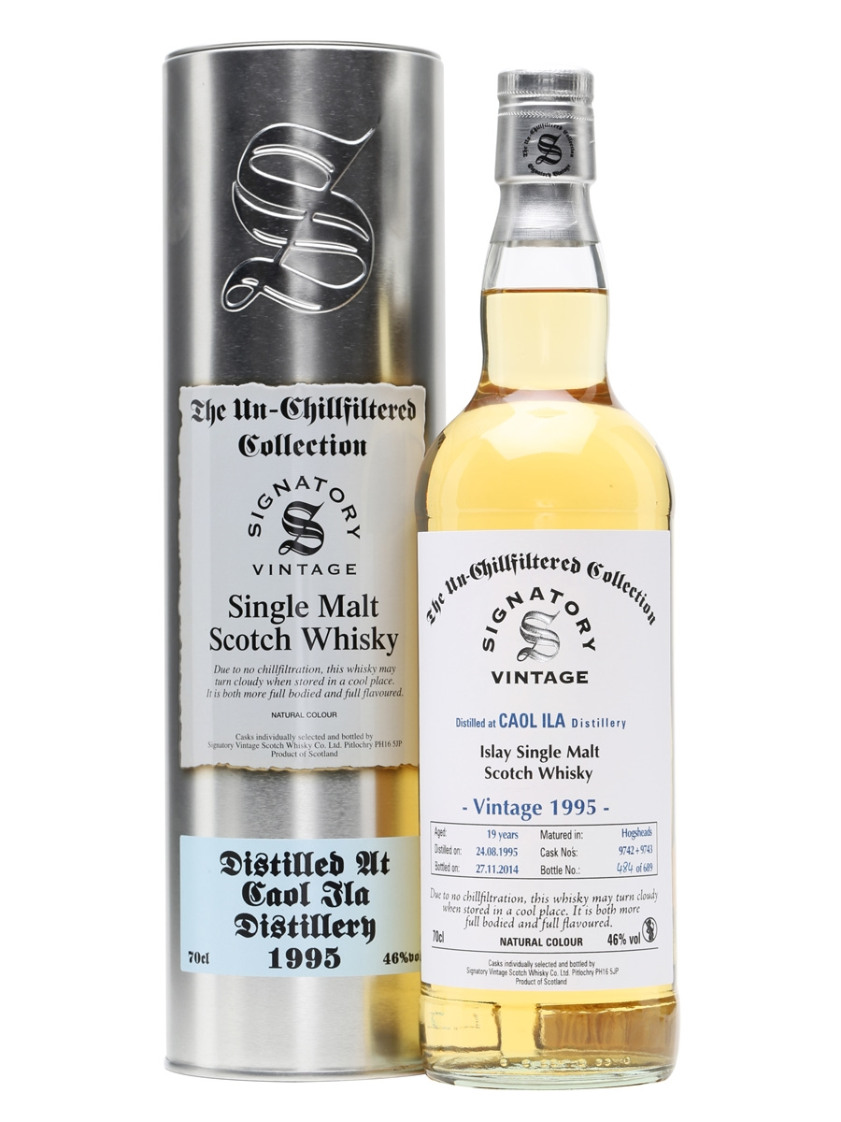

**AGED:** 19 years

**DISTILLED ON:** August 8, 1995

**BOTTLE ON:** October 14, 2014

**MATURED IN:** Hogshead

**CASK NO:** 9801

**BOTTLE NO:** of 295

_________________________________________

Caol Ila, pronounced ‘cull-eela’, is the Gaelic name for the Sound of Islay, in reference to the distillery's location overlooking the strait between Islay and Jura. Built in 1846, Caol Ila is the largest of the eight working distilleries on the island of Islay.

# TASTE NOTES

**COLOR**: white wine

**NOSE**: smoked cocktail made of oyster and lemon juice, traces of exhaust and burnt rubber "in a good way".

**TASTE**: same as nose, with touch of green olive, some wax and ashes, briny and a bit sour.

**FINISH**: long, zesty, and fresh.

C:\STOCKLAYOUTS\CURRENT PROJECTS\FN99807-PL\FN99807-IMG05.emf

Imported by Total Beverage Solution

www.SignatoryUSA.com

www.SignatoryScotch.com

IMPORTED BY TOTAL BEVERAGE SOLUTIONS