* 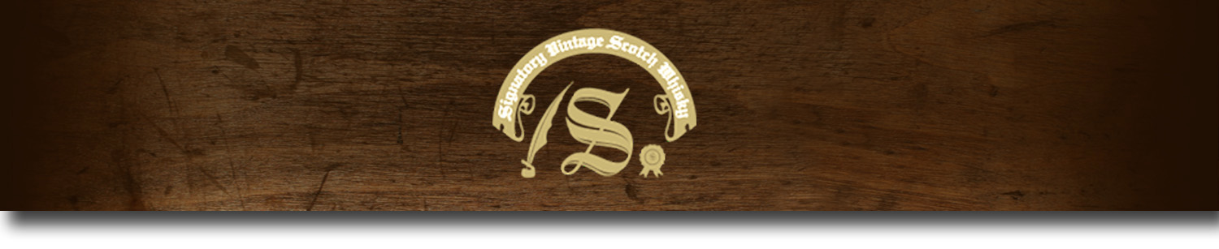Un-Chillfiltered Series -

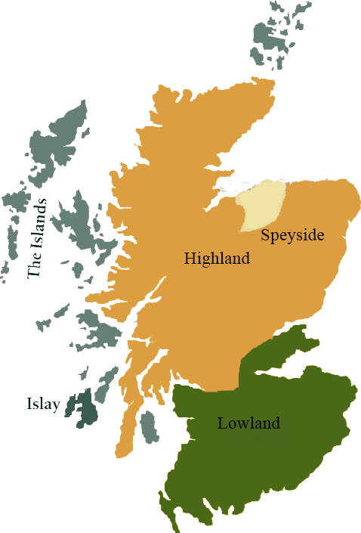*A comprehensive selection of natural strength whiskies, in individually numbered bottles, is available. This selection offers whiskies up to 35 years old, with rare malts being offered in a luxurious gift box with a certificate of authenticity.*

# Bowmore 2002

ISLAY REGION • HOGSHEAD

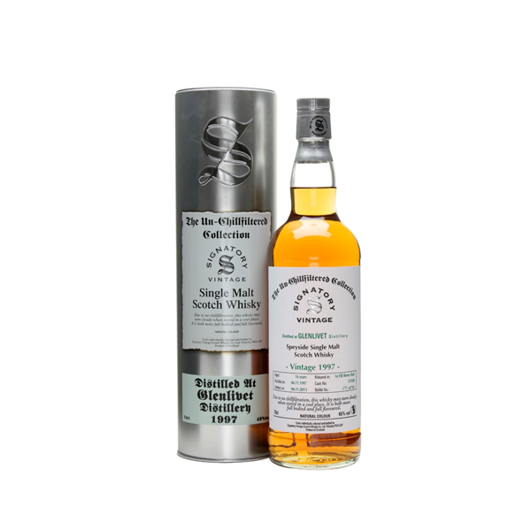

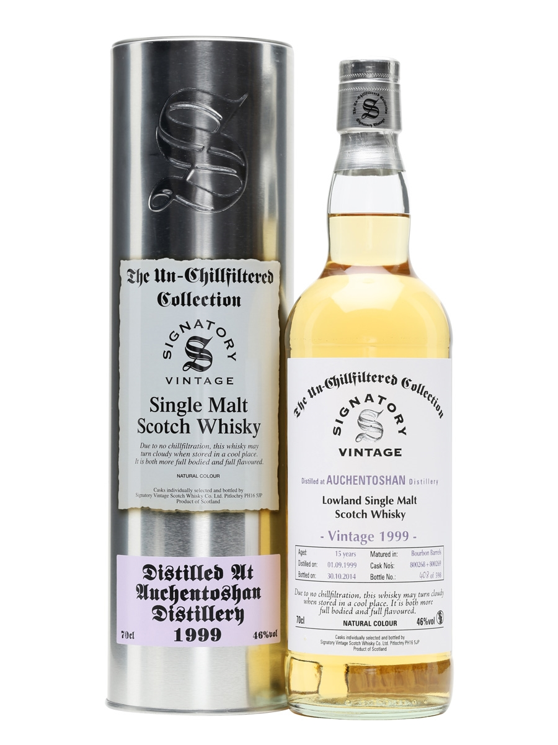

**AGED:** 12 years

**DISTILLED ON:** October 2, 2002

**BOTTLE ON:** October 23, 2014

**MATURED IN:** Hogshead

**CASK NO:** 2186

**BOTTLE NO:** of 321

_________________________________________

One of Scotland's oldest distilleries, Bowmore was opened by a local merchant in 1779. The distillery's location on Islay's Lcoh Indaal shore lends to the cool temperatures and peaty soil ideal for making whiskey. Since its establishment, Bowmore has continuously produced its own floor malted barley, which creates a balanced, flavorful spirit.

# TASTE NOTES

**COLOR**: warm amber

**NOSE**: subtle lemon and honey, balanced beautifully by Bowmore's trademark peaty smokiness.

**TASTE**: sweet and delicious heather honey and gentle peat smoke.

**FINISH**: long and mellow.

C:\STOCKLAYOUTS\CURRENT PROJECTS\FN99807-PL\FN99807-IMG05.emf

Imported by Total Beverage Solution

www.SignatoryUSA.com

www.SignatoryScotch.com

IMPORTED BY TOTAL BEVERAGE SOLUTIONS