* 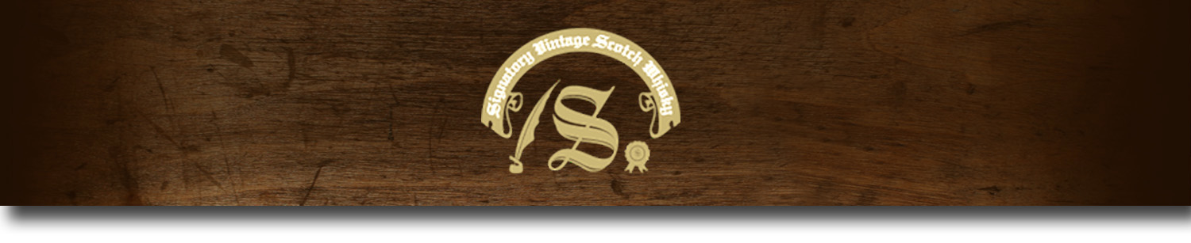Cask Strength Series -

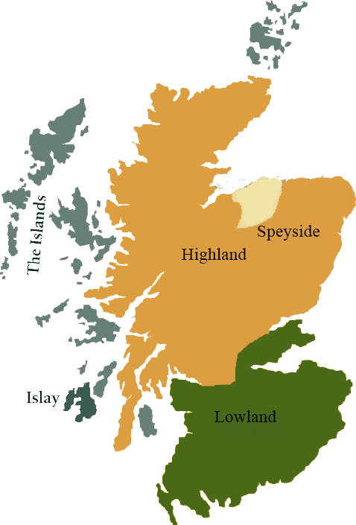*A comprehensive selection of natural strength whiskies, in individually numbered bottles, is available. This selection offers whiskies up to 35 years old, with rare malts being offered in a luxurious gift box with a certificate of authenticity.*

# Blair Athol 1988

HIGHLAND REGION • HOGSHEAD CASK

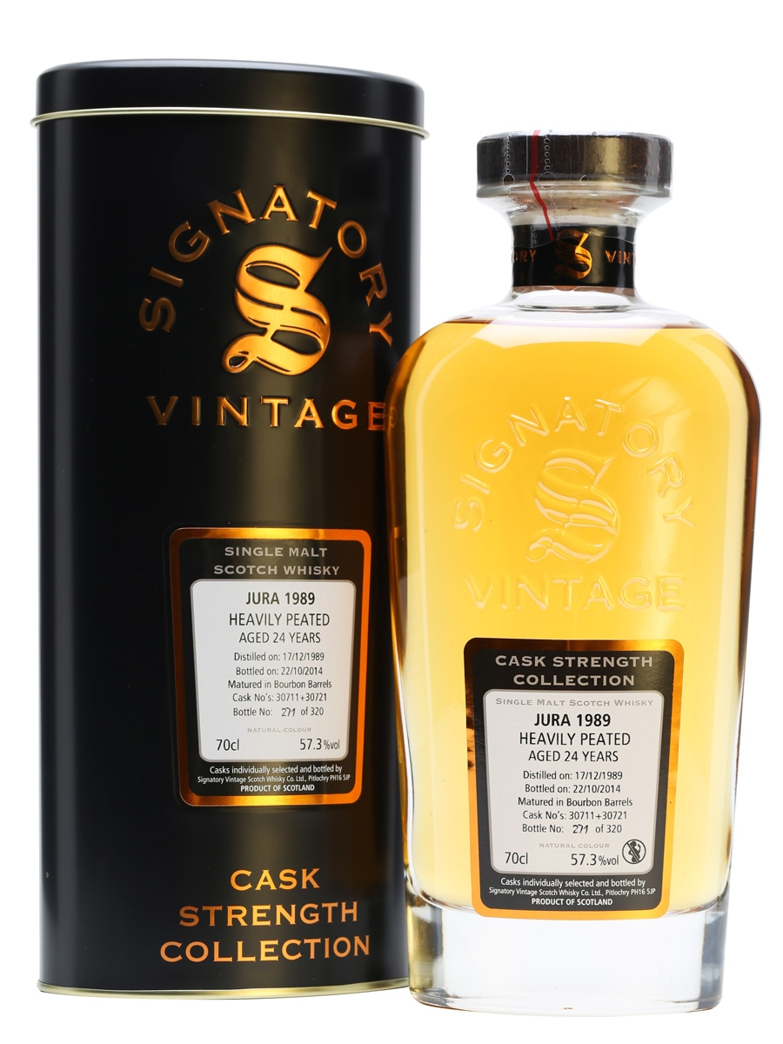

**AGED:** 25 years

**DISTILLED ON:** September 28, 1988

**BOTTLE ON:** September 17, 2014

**MATURED IN:** Hogshead

**CASK NO:** 6789

**BOTTLE NO:** of 471

_________________________________________

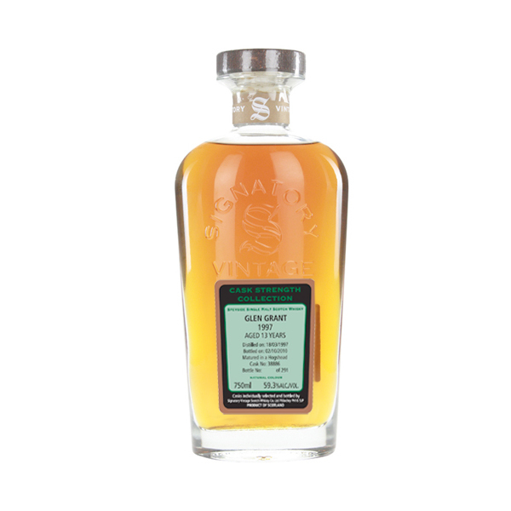

Founded in 1798, Blair Athol is one of Scotland's oldest distilleries. Blair Athol whiskey's, which are most famously found in Bell’s blends, use the water of the Allt Dourto to create their mellow, deep-toned malts.

# TASTE NOTES

**COLOR**: dark amber

**NOSE**: subtle mix of earth and cake, with a bit of burnt sugar underneath.

**TASTE**: The sherry influence is still quite fresh in the whisky as layers of cake, bread and Christmas spices come quickly on the entry, moving into a round, resinous fruit flavor that coats the palate, revealing brandied cherries and oily, earthier notes.

**FINISH**: long and earthy.

www.SignatoryUSA.com

C:\STOCKLAYOUTS\CURRENT PROJECTS\FN99807-PL\FN99807-IMG05.emf

Imported by Total Beverage Solutions

www.SignatoryScotch.com

IMPORTED BY TOTAL BEVERAGE SOLUTIONS