* 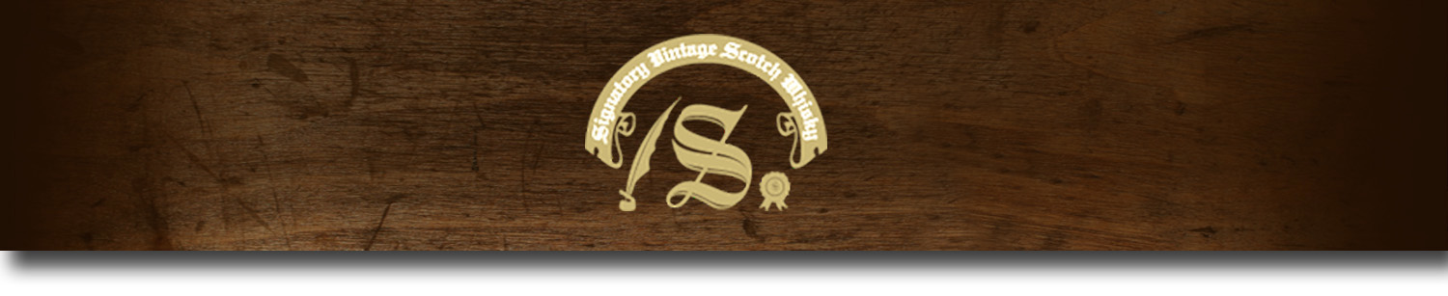86 Proof Series -

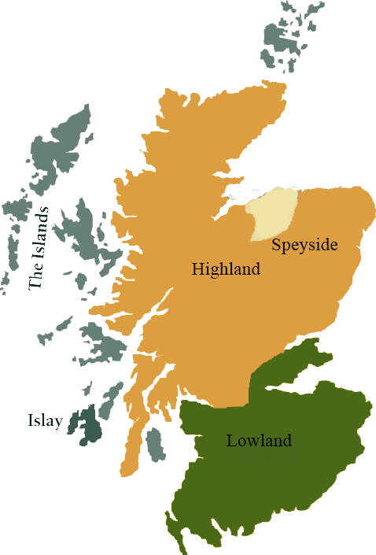*This collection offers a comprehensive range of single malts, up to 20 years old, from each of Scotland’s distilling regions. All are bottled at 86 proof, and are offered in color coordinated presentation tins with matching labels, identifying the region of distillation.*

# Benrinnes 1997

HIGHLAND REGION • HOGSHEAD CASK

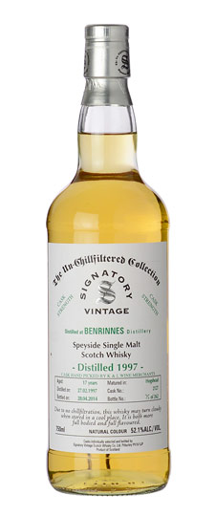

**AGED:** 17 years

**DISTILLED ON:** February 27, 1997

**BOTTLED ON:** July 28, 2014

**MATURED IN:** Hogshead

**CASK NO:** 2128

**BOTTLE NO:** of 358

_________________________________________

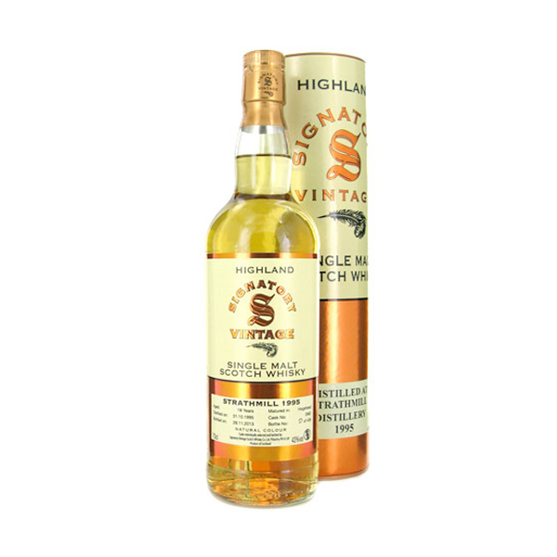

Benrinnes malt whiskey distillery has been producing its namesake whiskey since 1826. Though the original distillery was located on Peter Mckenzie's farm, the factory was rebuilt in 1835 after a flood destroyed the property. Most commonly used in blends such as Johnnie Walker and J&B, independent bottlings of Benrinnes are rare.

C:\STOCKLAYOUTS\CURRENT PROJECTS\FN99807-PL\FN99807-IMG05.emf

www.SignatoryUSA.com

# TASTE NOTES

**COLOR**: light gold

**NOSE**: fruits with a slight vanilla aroma.

**TASTE**: soft vanilla and a round, fruity palate.

**FINISH**: brandied cherries to sweet iced tea.

Imported by Total Beverage Solution

www.SignatoryScotch.com

IMPORTED BY TOTAL BEVERAGE SOLUTIONS