* 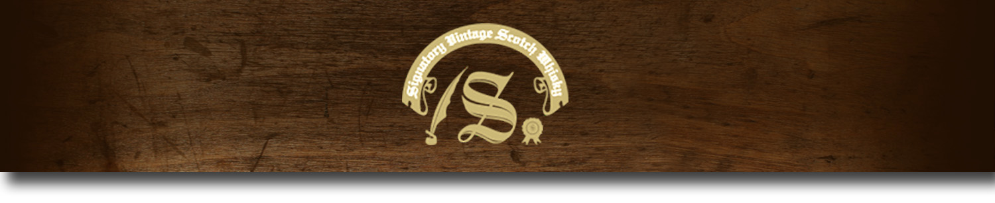Cask Strength Series -

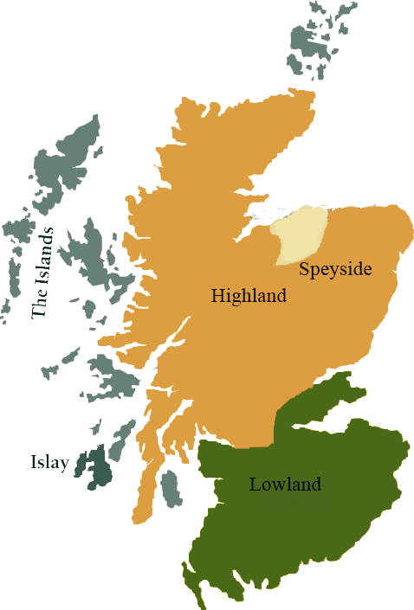*A comprehensive selection of natural strength whiskies, in individually numbered bottles, is available. This selection offers whiskies up to 35 years old, with rare malts being offered in a luxurious gift box with a certificate of authenticity.*

# Balmenach 1988

SPEYSIDE REGION • HOGSHEAD CASK

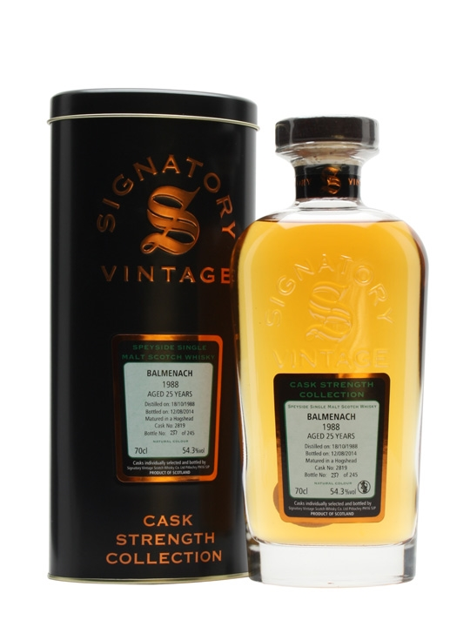

**AGED:** 25 years

**DISTILLED ON:** October 18, 1988

**BOTTLE ON:** September 17, 2014

**MATURED IN:** Hogshead

**CASK NO:** 2820

**BOTTLE NO:** of 222

_________________________________________

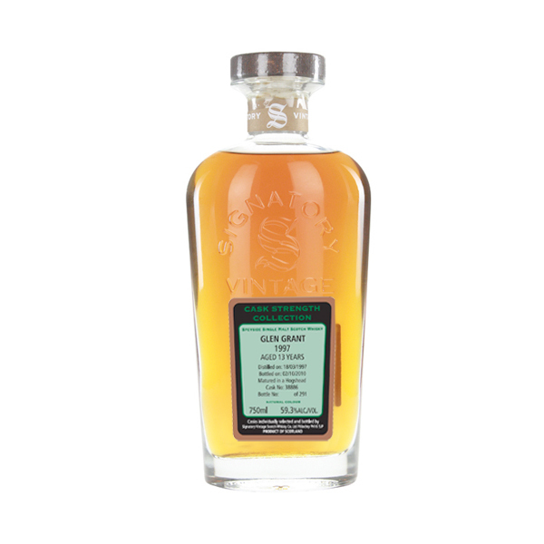

In the heart of whiskey country, Balmenach is nearly 200-years-old, and one of Speyside's first legally operated distilleries. Rarely sold as independent malts, Balmenach's spirits can be found in blends, such as Johnnie Walker.

# TASTE NOTES

**COLOR**: goldenrod

**NOSE**: fresh pineapple, unripe mango, banana and fruit salad chews, sweet vanilla cream with hints of woody spice, honey and touches of beeswax polish.

**TASTE**: thick, oily and spicy, with flavors of cinnamon custard up front, then sweet apple, banana, nectarine and touches of bitter apple skin.

**FINISH**: vanilla cream, touches of liquor ice root, woody spice (clove & cinnamon) and lingering sweet wood - freshly stripped willow branches.

www.SignatoryUSA.com

C:\STOCKLAYOUTS\CURRENT PROJECTS\FN99807-PL\FN99807-IMG05.emf

Imported by Total Beverage Solutions

www.SignatoryScotch.com

IMPORTED BY TOTAL BEVERAGE SOLUTIONS