* 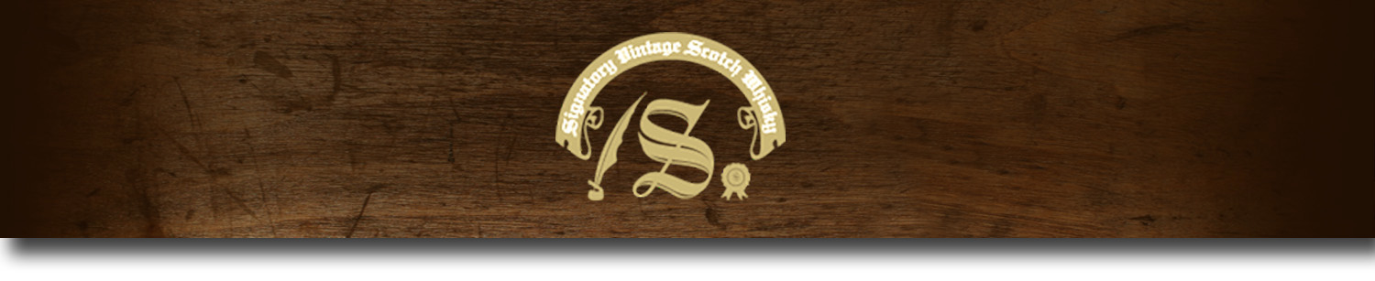Un-Chillfiltered Series -

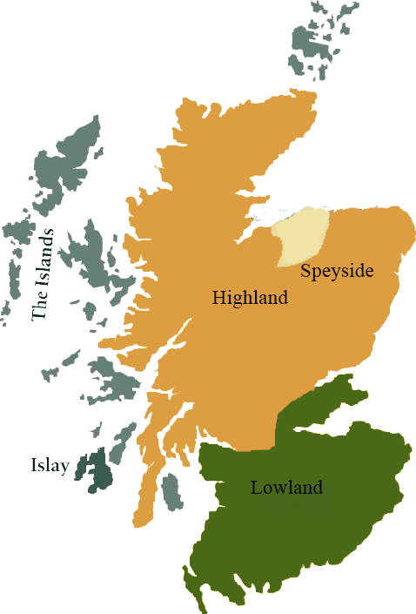*A comprehensive selection of natural strength whiskies, in individually numbered bottles, is available. This selection offers whiskies up to 35 years old, with rare malts being offered in a luxurious gift box with a certificate of authenticity.*

# Auchentoshan 1999

LOWLAND REGION • BOURBON BARREL

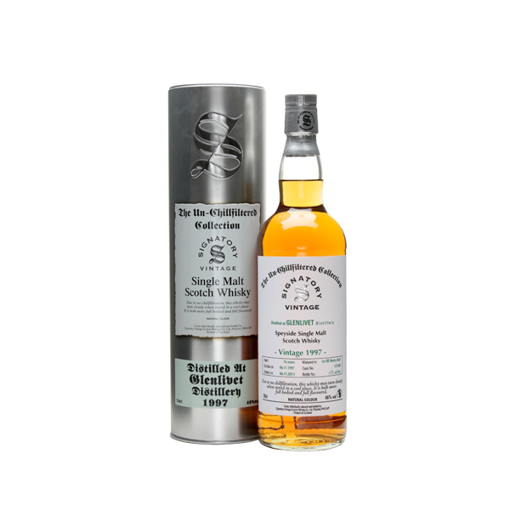

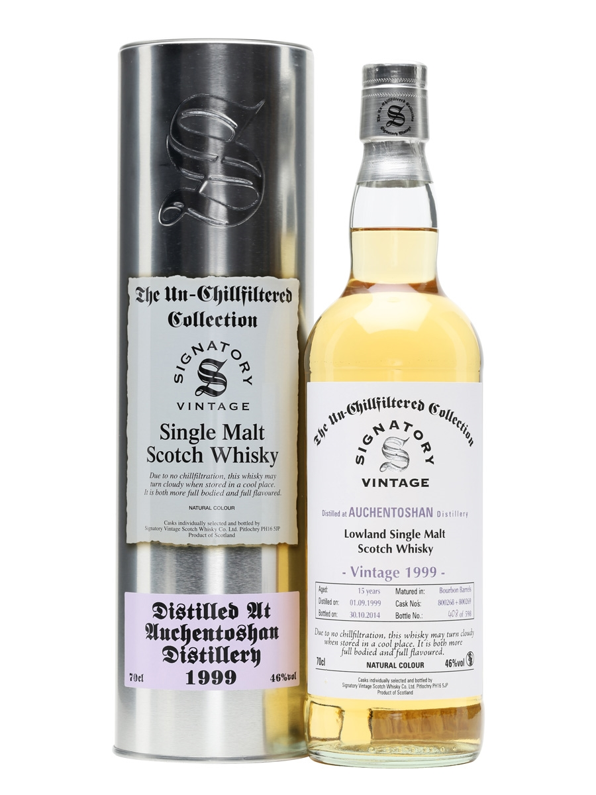

**AGED:** 15 years

**DISTILLED ON:** September 1, 1999

**BOTTLE ON:** October 13, 2014

**MATURED IN:** Bourbon Barrel

**CASK NO:** 800267

**BOTTLE NO:** of 267

_________________________________________

Gaelic for "the field of the corner," Auchentoshan is found in western Scotland's Lowland region. Located in the foothills of Kilpatrick, the distillery has been dubbed "Glasgow's Malt Whisky" due to its close proximity to the city. The distillery's triple distillation process gives the malts a delicate, sweeter flavor.

# TASTE NOTES

**COLOR**: pale lemony gold

**NOSE**: gingerbread, treacle, malty pear drops and strawberry jam.

**TASTE**: Milk chocolate, fruit and nuts, trifle sponge and biscuits.

**FINISH**: Minty smooth sweet finish, well rounded and medium bodied.

C:\STOCKLAYOUTS\CURRENT PROJECTS\FN99807-PL\FN99807-IMG05.emf

Imported by Total Beverage Solution

www.SignatoryUSA.com

www.SignatoryScotch.com

IMPORTED BY TOTAL BEVERAGE SOLUTIONS