* 86 Proof Series -

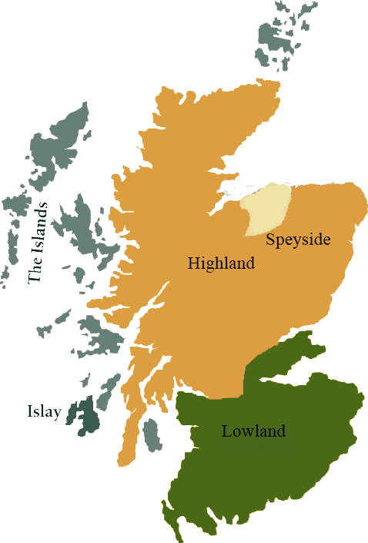*This collection offers a comprehensive range of single malts, up to 20 years old, from each of the distilling areas of Scotland. All bottled at 86 proof, and are offered in color coordinated presentation tins with matching labels, identifying the regions of distillation.*

# Tormore

HIGHLAND REGION • HOGSHEAD CASK

**AGED:** 16 years

**DISTILLED ON:** April 1995

**BOTTLE ON:** January 2014

**MATURED IN:** Hogshead

**CASK NO:** 1827

**BOTTLE NO:** of 398

_________________________________________

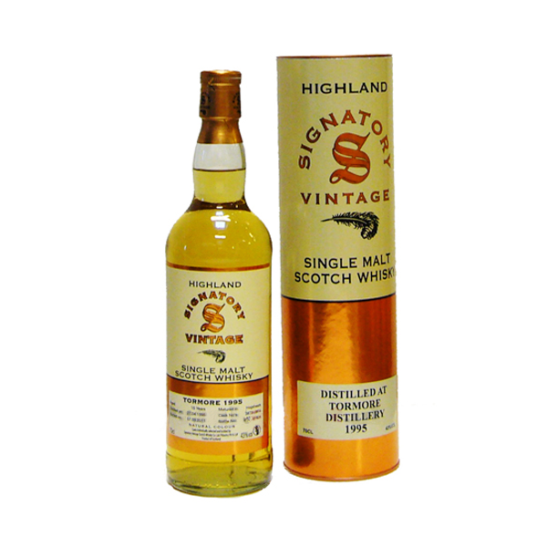

Tormore Distillery is one of the younger Scottish whiskies, the distillery construction began in 1958 and was completed in 1960. It was the first new distillery to be built in the country in the 20th century. Located in Speyside's Cromdale Hills in a rather picturesque spot overlooking the Spey.

# TASTE NOTES

**COLOR**: light straw

**NOSE**: fruity aroma, notes of apple pie, fudge and hints of freshly mown grass

**TASTE**: fruity flavor with light wood notes, some fudge and pastries

**FINISH**: long-lasting and sweet finish

C:\STOCKLAYOUTS\CURRENT PROJECTS\FN99807-PL\FN99807-IMG05.emf

Imported by Total Beverage Solution

www.SignatoryScotch.com

www.SignatoryScotch.com

IMPORTED BY TOTAL BEVERAGE SOLUTIONS