* 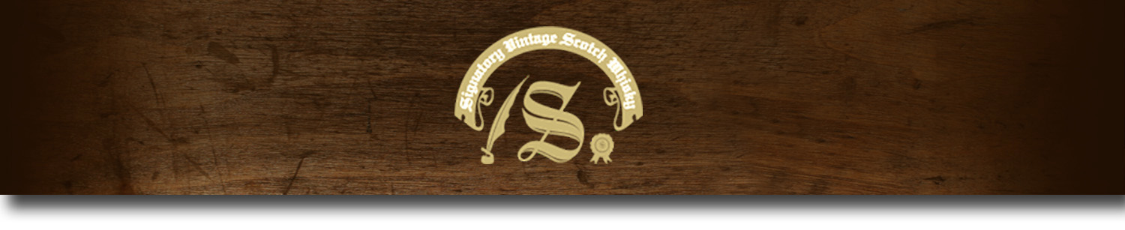Cask Strength Series -

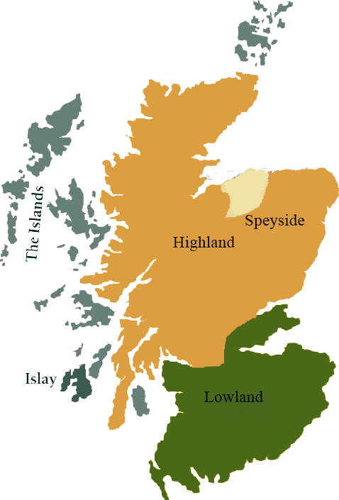*A comprehensive selection of natural strength whiskies, in individually numbered bottles, is available.This selection offers whiskies up to 35 years old, with rare malts being offered in a luxurious gift box with a certificate of authenticity.*

# Laphroaig 1996

ISLAY REGION • HOGSHEAD CASK

**AGED:** 17 years

**DISTILLED ON:** November 1996

**BOTTLE ON:** January 2014

**MATURED IN:** Hogshead

**CASK NO:** 8520

**BOTTLE NO:** of 232

_________________________________________

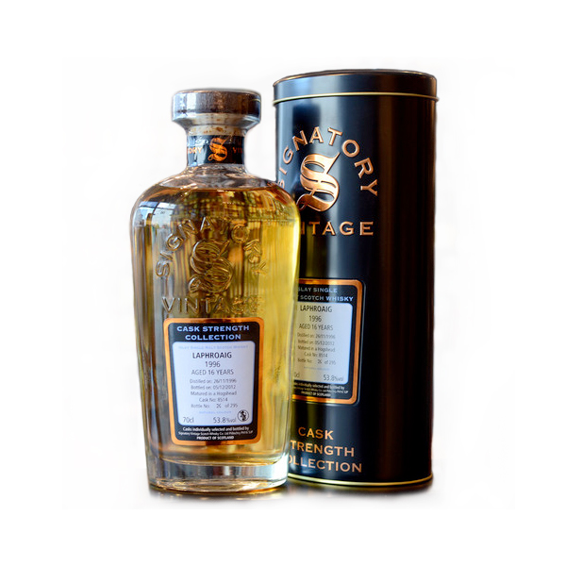

Set amongst the backdrop of the granite hills, strewn with the Neolithic standing stones used to mark the seasons stands the Laphroaig Distillery. For nearly 200 years a small team of dedicated islanders have worked at the distillery to create what is considered to be the most distinctive single malt in the world. While the team may change over the years, the traditional methods, ancient skills and absolute dedication to quality remains.

www.SignatoryScotch.com

Imported by Total Beverage Solution

# TASTE NOTES

**COLOR**: Rich deep gold

**NOSE**: Clean peat smoke and buttery toffee notes. A lovely hint of vanilla, as well as fresh oysters with lemon juice.

**TASTE**: Full and strong body. A rich palate with a massive peated burst of flavor with hints of sweetness and allspice at the end

**FINISH**: Long, spicy and savory.

C:\STOCKLAYOUTS\CURRENT PROJECTS\FN99807-PL\FN99807-IMG05.emf

www.SignatoryScotch.com

IMPORTED BY TOTAL BEVERAGE SOLUTIONS