* 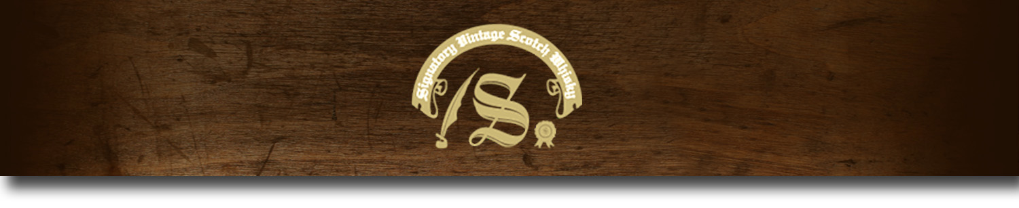Cask Strength Series -

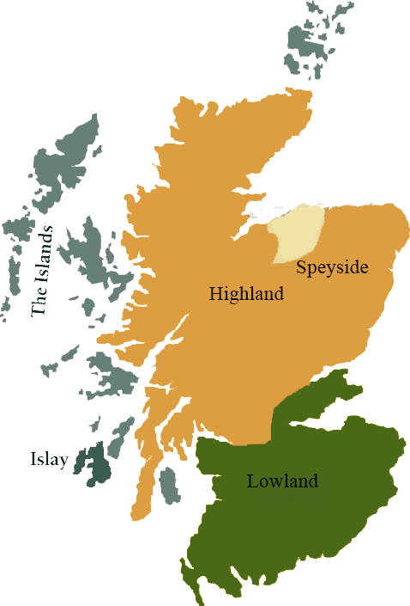*A comprehensive selection of natural strength whiskies, in individually numbered bottles, is available.This selection offers whiskies up to 35 years old, with rare malts being offered in a luxurious gift box with a certificate of authenticity.*

# Highland Park- New Cask 1988

ISLAY REGION • HOGSHEAD CASK

**AGED:** 25 years

**DISTILLED ON:** June 1988

**BOTTLE ON:** May 2014

**MATURED IN:** Hogshead

**CASK NO:** 749

**BOTTLE NO:** of 216

_________________________________________

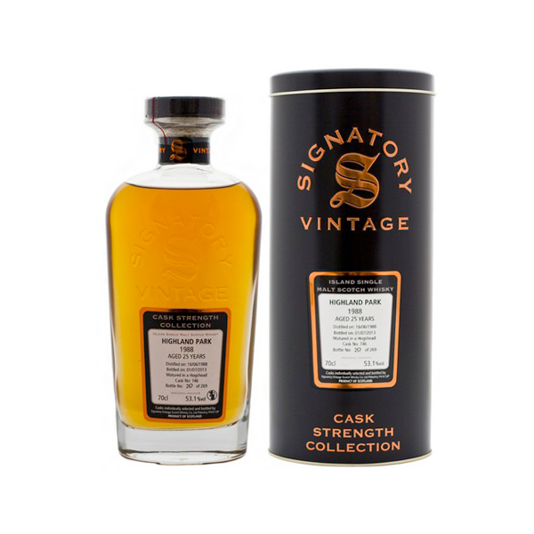

Highland Park is made today with the same enduring belief and integrity, to the same exacting standards, as it has been since 1798. The established attitude at Highland Park Distillery is one of custodianship rather than management, of tradition rather than novelty. That’s not to say the distillery is stuck in the mud – far from it – but innovation is only used when there is a genuine benefit to the whisky not, as is often the way, a benefit to efficiency or profitability.

# TASTE NOTES

**COLOR**: Rich deep gold

**NOSE**: Clean peat smoke and buttery toffee notes. A lovely hint of vanilla, as well as fresh oysters with lemon juice.

**TASTE**: Full and strong body. A rich palate with a massive peated burst of flavor with hints of sweetness and allspice at the end

**FINISH**: Long, spicy and savory.

C:\STOCKLAYOUTS\CURRENT PROJECTS\FN99807-PL\FN99807-IMG05.emf

Imported by Total Beverage Solution

www.SignatoryScotch.com

www.SignatoryScotch.com

IMPORTED BY TOTAL BEVERAGE SOLUTIONS