* 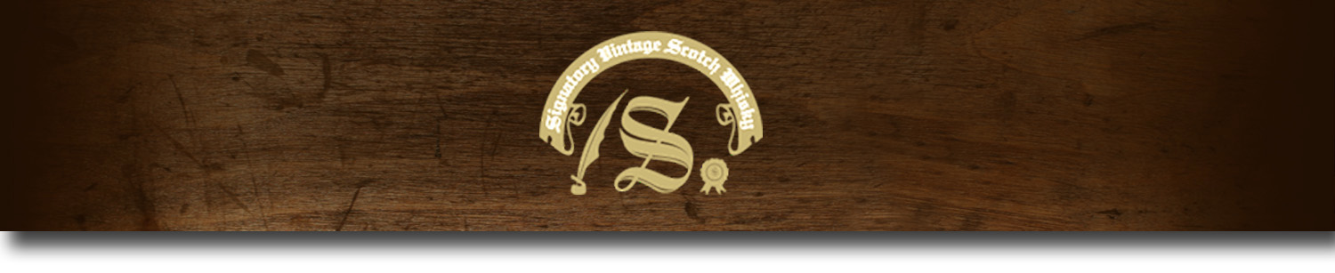Un-Chillfiltered Series -

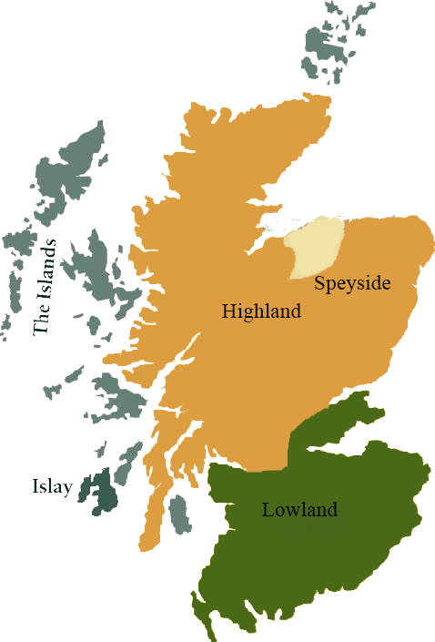*A comprehensive selection of natural strength whiskies, in individually numbered bottles, is available.This selection offers whiskies up to 35 years old, with rare malts being offered in a luxurious gift box with a certificate of authenticity.*

# Glenlivet 1997

SPEYSIDE REGION • SHERRY BUTT

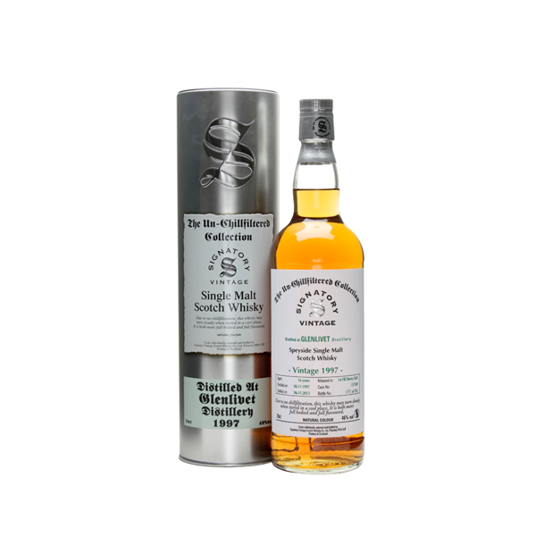

**AGED:** 16 years

**DISTILLED ON:** June 1997

**BOTTLE ON:** May 2014

**MATURED IN:** Hogshead

**CASK NO:** 157422

**BOTTLE NO:** of 738

_________________________________________

The Glenlivet Distillery located near Ballindalloch in Moray, Scotland produces single malt Scotch whisky. It is the oldest legal distillery in the parish of Glenlivet. It has been described as "The single malt that started it all.” The distillery has been in operation almost continuously since it was founded in 1824.

# TASTE NOTES

**COLOR**: Reddish amber

**NOSE**: Gunpowder and blood oranges at first nosing. Absolutely no straight sulphury notes, just ‘gunpowder’. Then chocolate, Spanish ham, black raisins, soot, cigars, blackcurrants, menthol and figs.

**TASTE**: Christmassy, with many dried fruits and a touch of liquorice and smoke. Dark chocolate, black raisins, dried figs, prunes, more liquorice… It’s one of these sherried malts that hint at old Armagnac.

**FINISH**: Long, more on bitter oranges and pepper. Honeydew and mint in the aftertaste.

C:\STOCKLAYOUTS\CURRENT PROJECTS\FN99807-PL\FN99807-IMG05.emf

Imported by Total Beverage Solution

www.SignatoryScotch.com

www.SignatoryScotch.com

IMPORTED BY TOTAL BEVERAGE SOLUTIONS