* 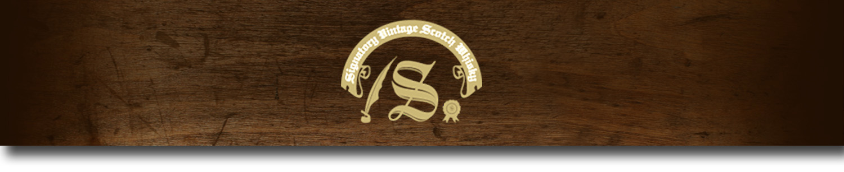Un-Chillfiltered Series -

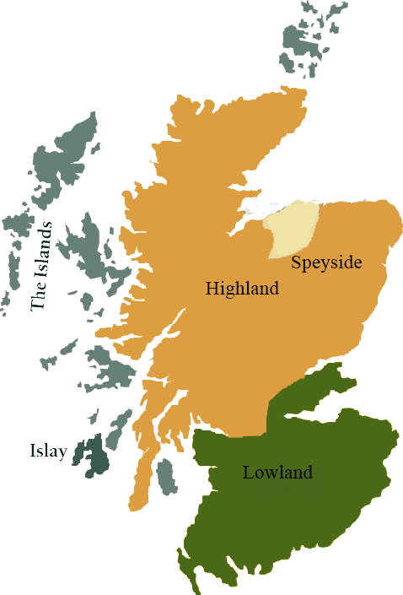*A comprehensive selection of natural strength whiskies, in individually numbered bottles, is available.This selection offers whiskies up to 35 years old, with rare malts being offered in a luxurious gift box with a certificate of authenticity.*

# Glen Rothes 1999

SPEYSIDE REGION • HOGSHEAD CASK

**AGED:** 14 years

**DISTILLED ON:** November 1999

**BOTTLE ON:** May 2014

**MATURED IN:** Hogshead

**CASK NO:** 12572

**BOTTLE NO:** of 358

_________________________________________

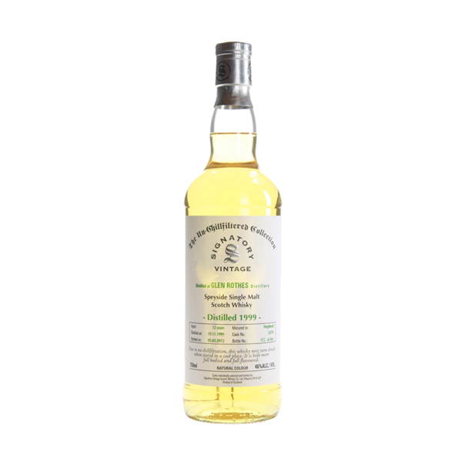

The Glenrothes Distillery has always been universally acclaimed by blenders as an exceptional Speyside Malt. The Glenrothes is used in blended scotch whiskies such as Cutty Sark and The Famous Grouse. The Glenrothes bottlings are not determined by age but by vintage, making this single malt unique in its category. The Glenrothes is also sold as "Select Reserve,” a recently introduced non-vintage line.

# TASTE NOTES

**COLOR**: Slightly rosy hue

**NOSE**: A rich sherried nose with brandy butter. Fairly strong sulphur notes with burnt sawdust and bread with some light fruit elements such as strawberries on top.

**TASTE**: Sulphur, cordite with deviled eggs. Chewy with a pepper taste like rocket.

**FINISH**: Long, with a fruity yet liquorice finish

C:\STOCKLAYOUTS\CURRENT PROJECTS\FN99807-PL\FN99807-IMG05.emf

Imported by Total Beverage Solution

www.SignatoryScotch.com

www.SignatoryScotch.com

IMPORTED BY TOTAL BEVERAGE SOLUTIONS