* 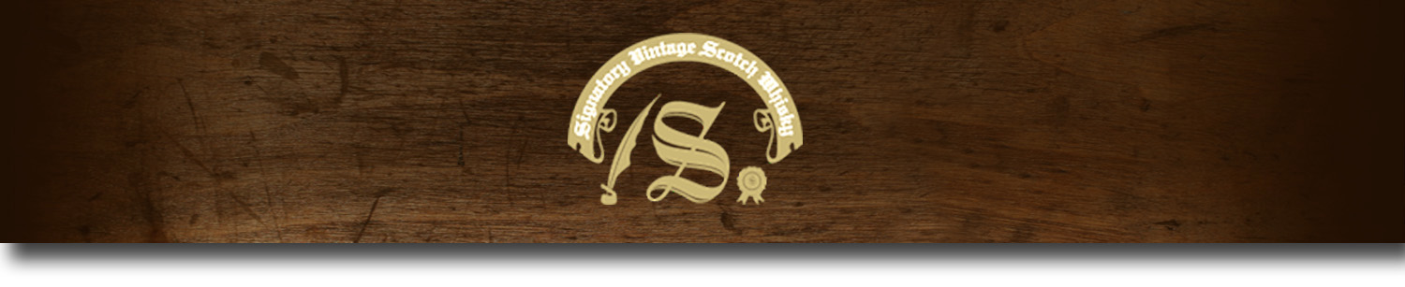86 Proof Series -

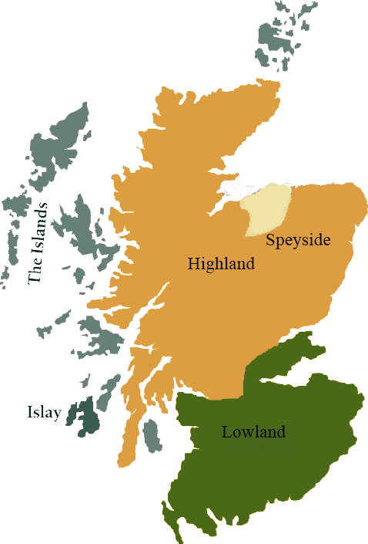*This collection offers a comprehensive range of single malts, up to 20 years old, from each of the distilling areas of Scotland. All bottled at 86 proof, and are offered in color coordinated presentation tins with matching labels, identifying the regions of distillation.*

# Glen Grant 1997

HIGHLAND REGION • HOGSHEAD CASK

**AGED:** 16 years

**DISTILLED ON:** March 1997

**BOTTLE ON:** January 2014

**MATURED IN:** Hogshead

**CASK NO:** 38887

**BOTTLE NO:** of 418

_________________________________________

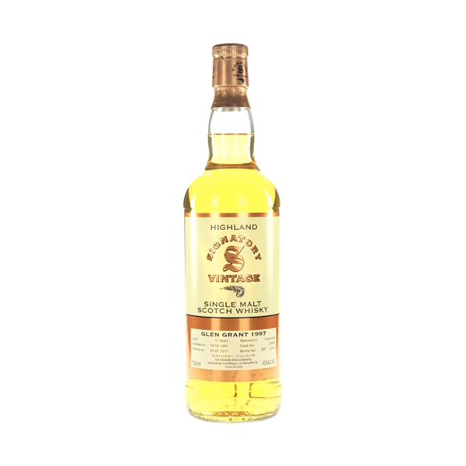

Glen Grant Distillery, built in 1840 by brothers, John and James Grant, is located in the heart of Speyside. The distillery is now the world’s second-largest single malt whiskey brand.

# TASTE NOTES

**COLOR**: light amber

**NOSE**: white grapes, a free apple tart and ripe pears

**TASTE**: similar to the nose, with some vanilla, oak and white pepper

**FINISH**: A medium finish

C:\STOCKLAYOUTS\CURRENT PROJECTS\FN99807-PL\FN99807-IMG05.emf

Imported by Total Beverage Solution

www.SignatoryScotch.com

www.SignatoryScotch.com

IMPORTED BY TOTAL BEVERAGE SOLUTIONS