* 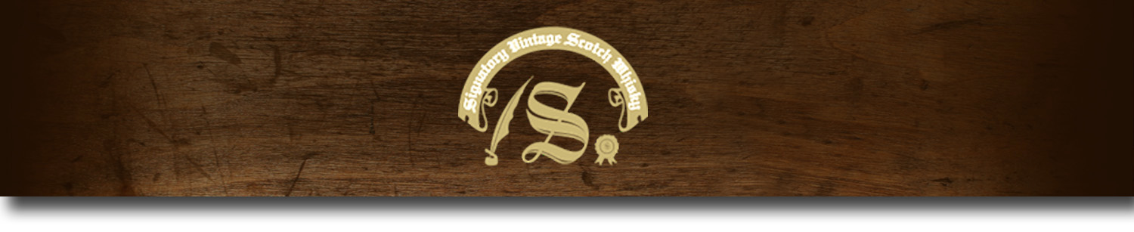Un-Chillfiltered Series -

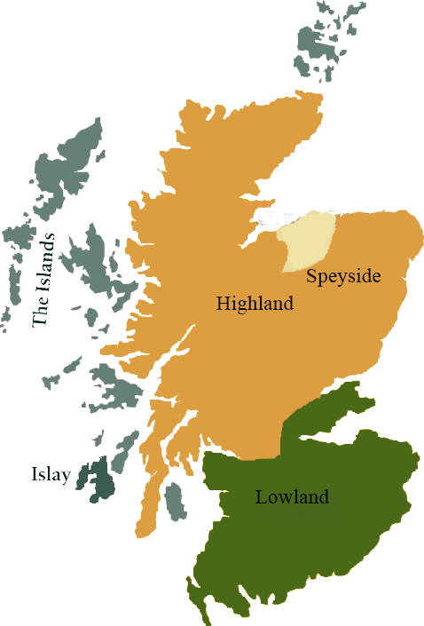*A comprehensive selection of natural strength whiskies, in individually numbered bottles, is available.This selection offers whiskies up to 35 years old, with rare malts being offered in a luxurious gift box with a certificate of authenticity.*

# Glen Elgin 1995

SPEYSIDE REGION • HOGSHEAD

**AGED:** 17 years

**DISTILLED ON:** July 1995

**BOTTLE ON:** September 2013

**MATURED IN:** Hogshead

**CASK NO:** 1640

**BOTTLE NO:** of 362

_________________________________________

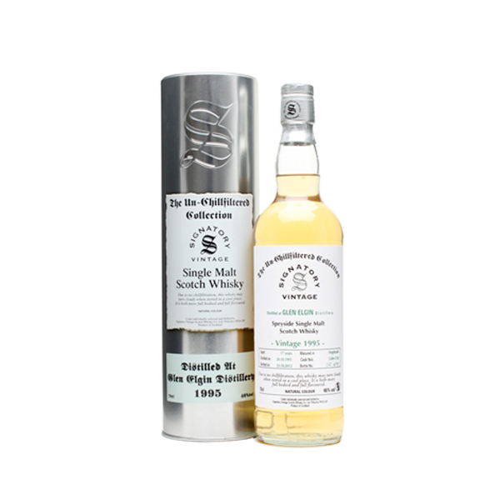

Glen Elgin is an unusually distinctive Speyside single malt from a little-known traditional distillery, that finds its home 10 miles south of where the river Lossie exits to the sea and about 40 miles east of Inverness. Founded at the end of the whisky boom in 1898, it was built and designed by the notable distillery architect Charles Doig of Elgin.

# TASTE NOTES

**COLOR**: Light banana golden

**NOSE**: Slight stewed apples. Cinnamon. Nuttiness. Slight black cherries. Condensed cream. Apricot. Slight pepper.

**TASTE**: Lime and nutty behind. Apricot and apples. Peppery late on. Toffee sweet. Water brings out more toffee and apples. Toffee and chocolate with more water.

**FINISH**: Peppery. Barley. Slight salty mild cheese. Nutty. Fudge. Water adds chocolate. Water makes mainly fudge and chocolate with a hint of spiced apricot.

C:\STOCKLAYOUTS\CURRENT PROJECTS\FN99807-PL\FN99807-IMG05.emf

Imported by Total Beverage Solution

www.SignatoryScotch.com

www.SignatoryScotch.com

IMPORTED BY TOTAL BEVERAGE SOLUTIONS