* 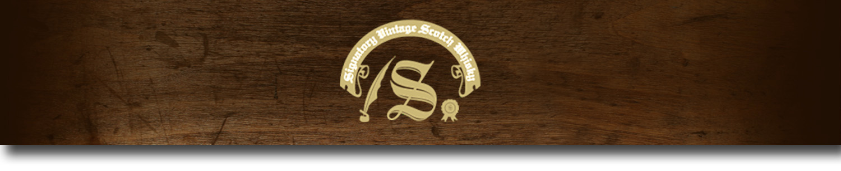Un-Chillfiltered Series -

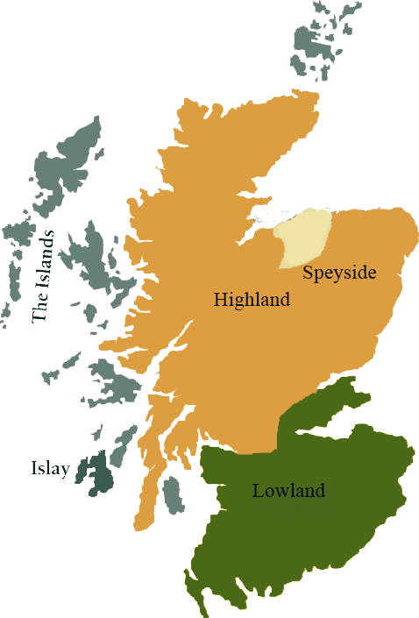*A comprehensive selection of natural strength whiskies, in individually numbered bottles, is available.This selection offers whiskies up to 35 years old, with rare malts being offered in a luxurious gift box with a certificate of authenticity.*

# Deanston 1997

HIGHLAND REGION • REFILL SHERRY

**AGED:** 16 years

**DISTILLED ON:** June 1997

**BOTTLE ON:** September 2013

**MATURED IN:** Hogshead

**CASK NO:** 1345

**BOTTLE NO:** of 719

_________________________________________

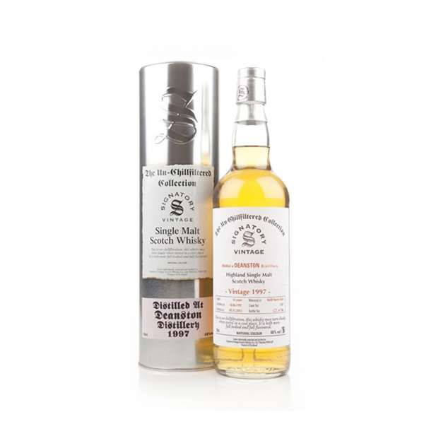

Deanston distillery is a Single malt Scotch whisky distillery located on the banks of the River Teith. Once a cotton mill, the building was transformed into a distillery in 1966 where it continues to produce an outstanding Highland single malt Whisky to this day. The whisky is handmade, un-chillfiltered naturally colored and bottled at a strength of 46.3%.

# TASTE NOTES

**COLOR**: Caramel

**NOSE**: A sharp spice with fresh ginger snaps, tangy cardamom and crushed black pepper. Behind this comes a slightly soapy floral aroma quickly pushed aside by notes of sour apples and zesty oranges. A creamy toffee with pineapple chunk sweets finishes off this interesting dram.

**TASTE**: The sweet and the spice from the nose flow together to create a very warming impression. Lemons and limes (zest and all) are thrown into the mix.

**FINISH**: Syrupy toasted malt and charcoal finish.

C:\STOCKLAYOUTS\CURRENT PROJECTS\FN99807-PL\FN99807-IMG05.emf

Imported by Total Beverage Solution

www.SignatoryScotch.com

www.SignatoryScotch.com

IMPORTED BY TOTAL BEVERAGE SOLUTIONS