* 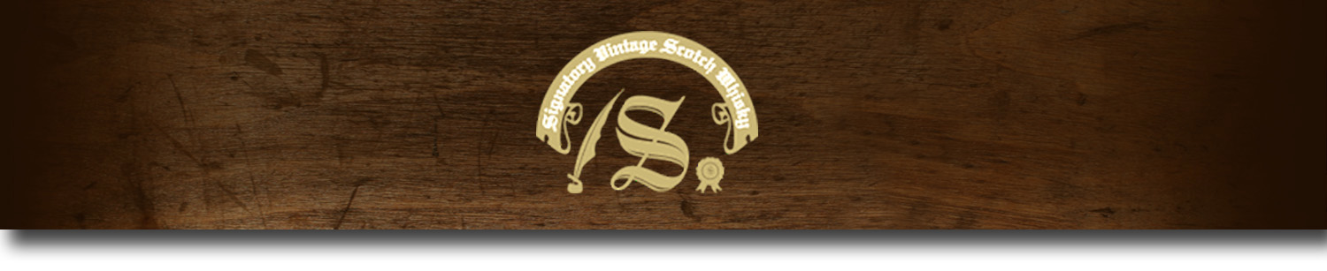Cask Strength Series -

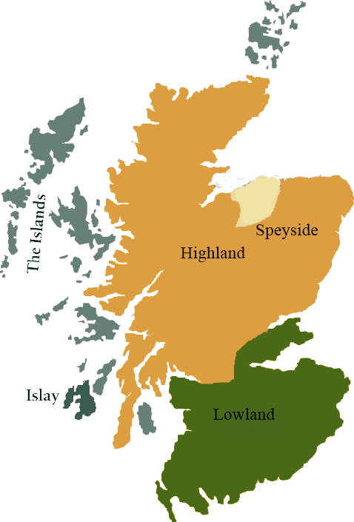*A comprehensive selection of natural strength whiskies, in individually numbered bottles, is available.This selection offers whiskies up to 35 years old, with rare malts being offered in a luxurious gift box with a certificate of authenticity.*

# Caol IIa 1983

ISLAY • HOGSHEAD CASK

**AGED:** 30 years

**DISTILLED ON:** October 1983

**BOTTLE ON:** January 2014

**MATURED IN:** Hogshead

**CASK NO:** 5301

**BOTTLE NO:** 253

_________________________________________

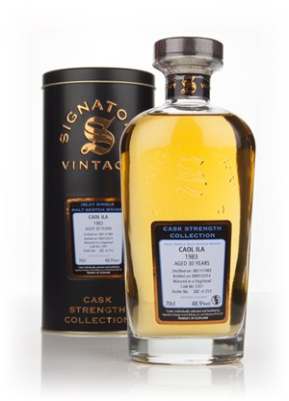

Caol Ila, pronounced ‘cull-eela’, is the Gaelic name for the Sound of Islay, in reference to the distillery's location overlooking the strait between Islay and Jura. Built in 1846, Caol Ila is the largest of the eight working distilleries on the island of Islay.

# TASTE NOTES

**COLOR**: caramel

**NOSE:** Fruity and tangy with notes of salty butter, toast, wet stones on a beach, linseed oil, a little peat smoke, kippers and sweetness.

**TASTE:** Rich and tangy palate, with good spice notes, citrus peels, black pepper, malt and smoke. A little smoked oyster note.

**FINISH:** Spicy, fruity and peaty. A little burning cardboard.

C:\STOCKLAYOUTS\CURRENT PROJECTS\FN99807-PL\FN99807-IMG05.emf

Imported by Total Beverage Solution

www.SignatoryScotch.com

www.SignatoryScotch.com

IMPORTED BY TOTAL BEVERAGE SOLUTIONS