* 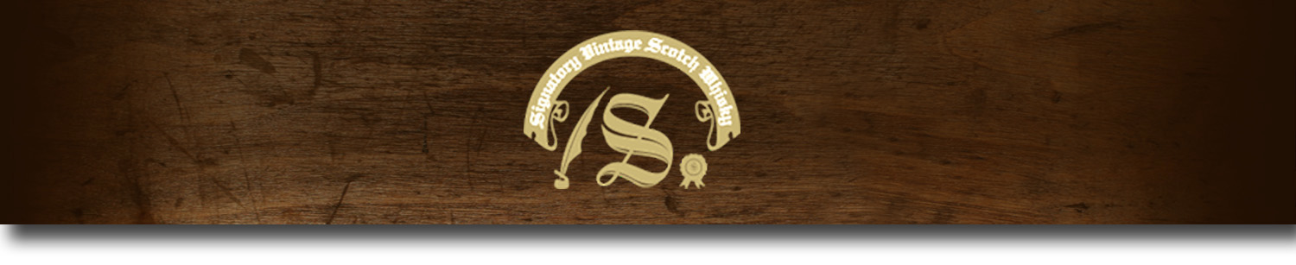Un-Chillfiltered Series -

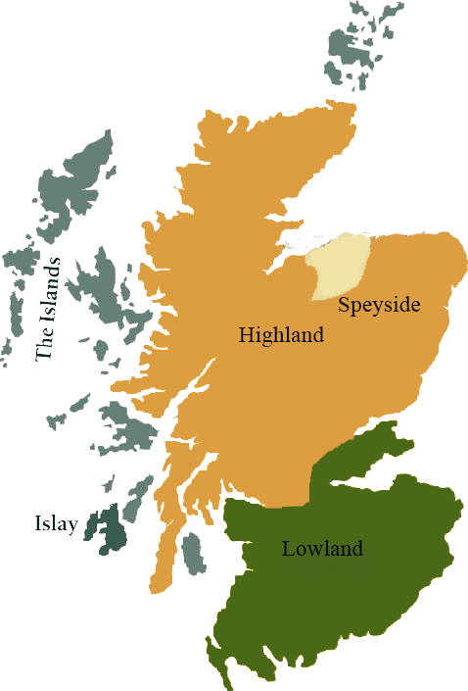*A comprehensive selection of natural strength whiskies, in individually numbered bottles, is available.This selection offers whiskies up to 35 years old, with rare malts being offered in a luxurious gift box with a certificate of authenticity.*

# Bruichladdich 1992

ISLAY REGION • HOGSHEAD CASK

**AGED:** 22 years

**DISTILLED ON:** April 1992

**BOTTLE ON:** May 2014

**MATURED IN:** Hogshead

**CASK NO:** 1386

**BOTTLE NO:** of 288

_________________________________________

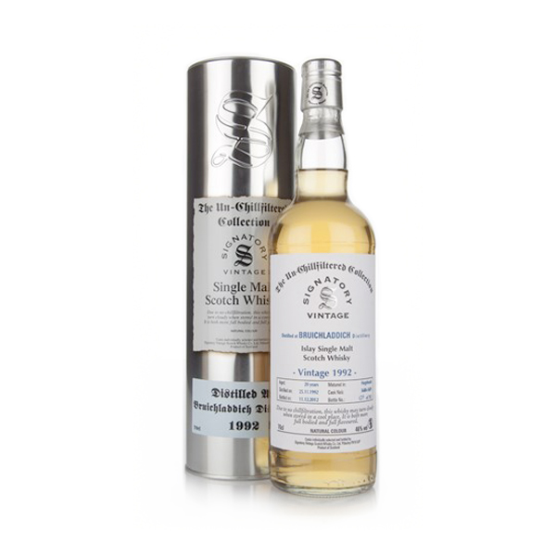

Bruichladdich Distillery is located on the Rhinns of the isle of Islay in Scotland. The distillery produces mainly single malt Scotch whisky, but has also offered artisanal gin. It is owned by Rémy Cointreau and is one of eight working distilleries on the island.

Imported by Total Beverage Solution

www.SignatoryScotch.com

# TASTE NOTES

**COLOR**: Honey

**NOSE**: Gentle aromas of sweet caramel and spice, hints of cooked fruit, barley wine and allspice.

**TASTE**: Spiced palate entry with notes of dried grass and star anise. A little Seville orange marmalade, soft smoke and something vaguely coastal.

**FINISH**: Ground almonds and black pepper. Sweet honey.

C:\STOCKLAYOUTS\CURRENT PROJECTS\FN99807-PL\FN99807-IMG05.emf

www.SignatoryScotch.com

IMPORTED BY TOTAL BEVERAGE SOLUTIONS