* 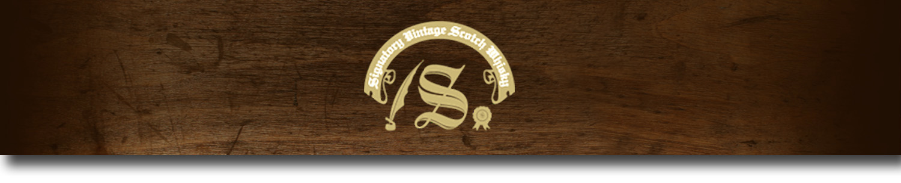Un-Chillfiltered Series -

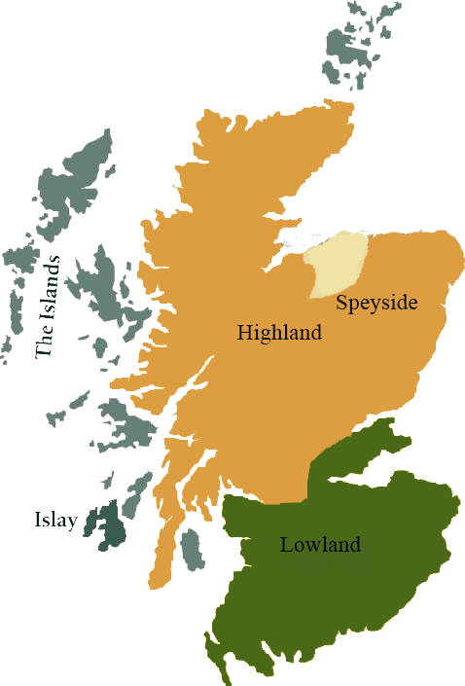*A comprehensive selection of natural strength whiskies, in individually numbered bottles, is available.This selection offers whiskies up to 35 years old, with rare malts being offered in a luxurious gift box with a certificate of authenticity.*

# Auchentoshan 1999

LOWLAND REGION • BOURBON CASK

**AGED:** 14 years

**DISTILLED ON:** January 1999

**BOTTLE ON:** May 2014

**MATURED IN:** Hogshead

**CASK NO:** 800250

**BOTTLE NO:** of 269

_________________________________________

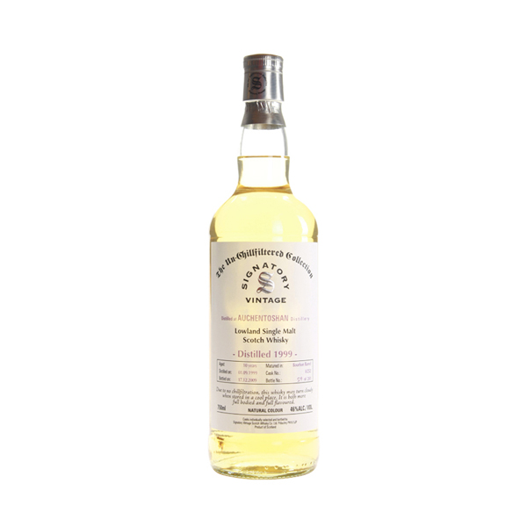

Auchentoshan distillery (pronounced Aw-khen-tosh-an) is a single malt whisky distillery in the west of Scotland. The distillery is also known as "Glasgow's Malt Whisky" due to its close proximity to Glasgow and "the breakfast whisky" due to its sweet and delicate nature. It is one of six malt whisky distilleries in the Scottish Lowlands

C:\STOCKLAYOUTS\CURRENT PROJECTS\FN99807-PL\FN99807-IMG05.emf

www.SignatoryScotch.com

Imported by Total Beverage Solution

# TASTE NOTES

**COLOR**: Pale yellowish

**NOSE**: Oats, honey, hints of cut grass, citrus fruit, cocoa and barley.

**TASTE**: Sweet, Crema Catalana, candy floss and toffee apples.

**FINISH**: Spicy with good length, nutmeg.

www.SignatoryScotch.com

IMPORTED BY TOTAL BEVERAGE SOLUTIONS