* 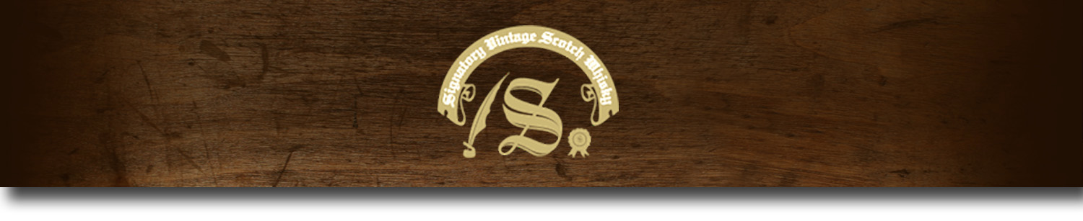86 Proof Series -

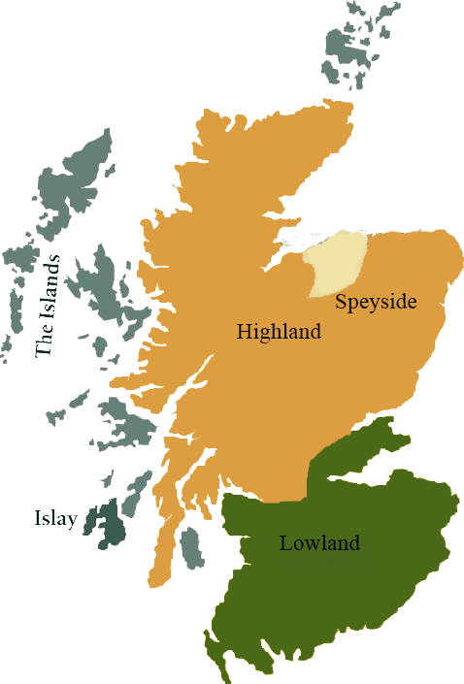*This collection offers a comprehensive range of single malts, up to 20 years old, from each of Scotland’s distilling regions. All are bottled at 86 proof, and are offered in color coordinated presentation tins with matching labels, identifying the region of distillation.*

# Mortlach 2000

HIGHLANDS REGION • HOGSHEAD CASK

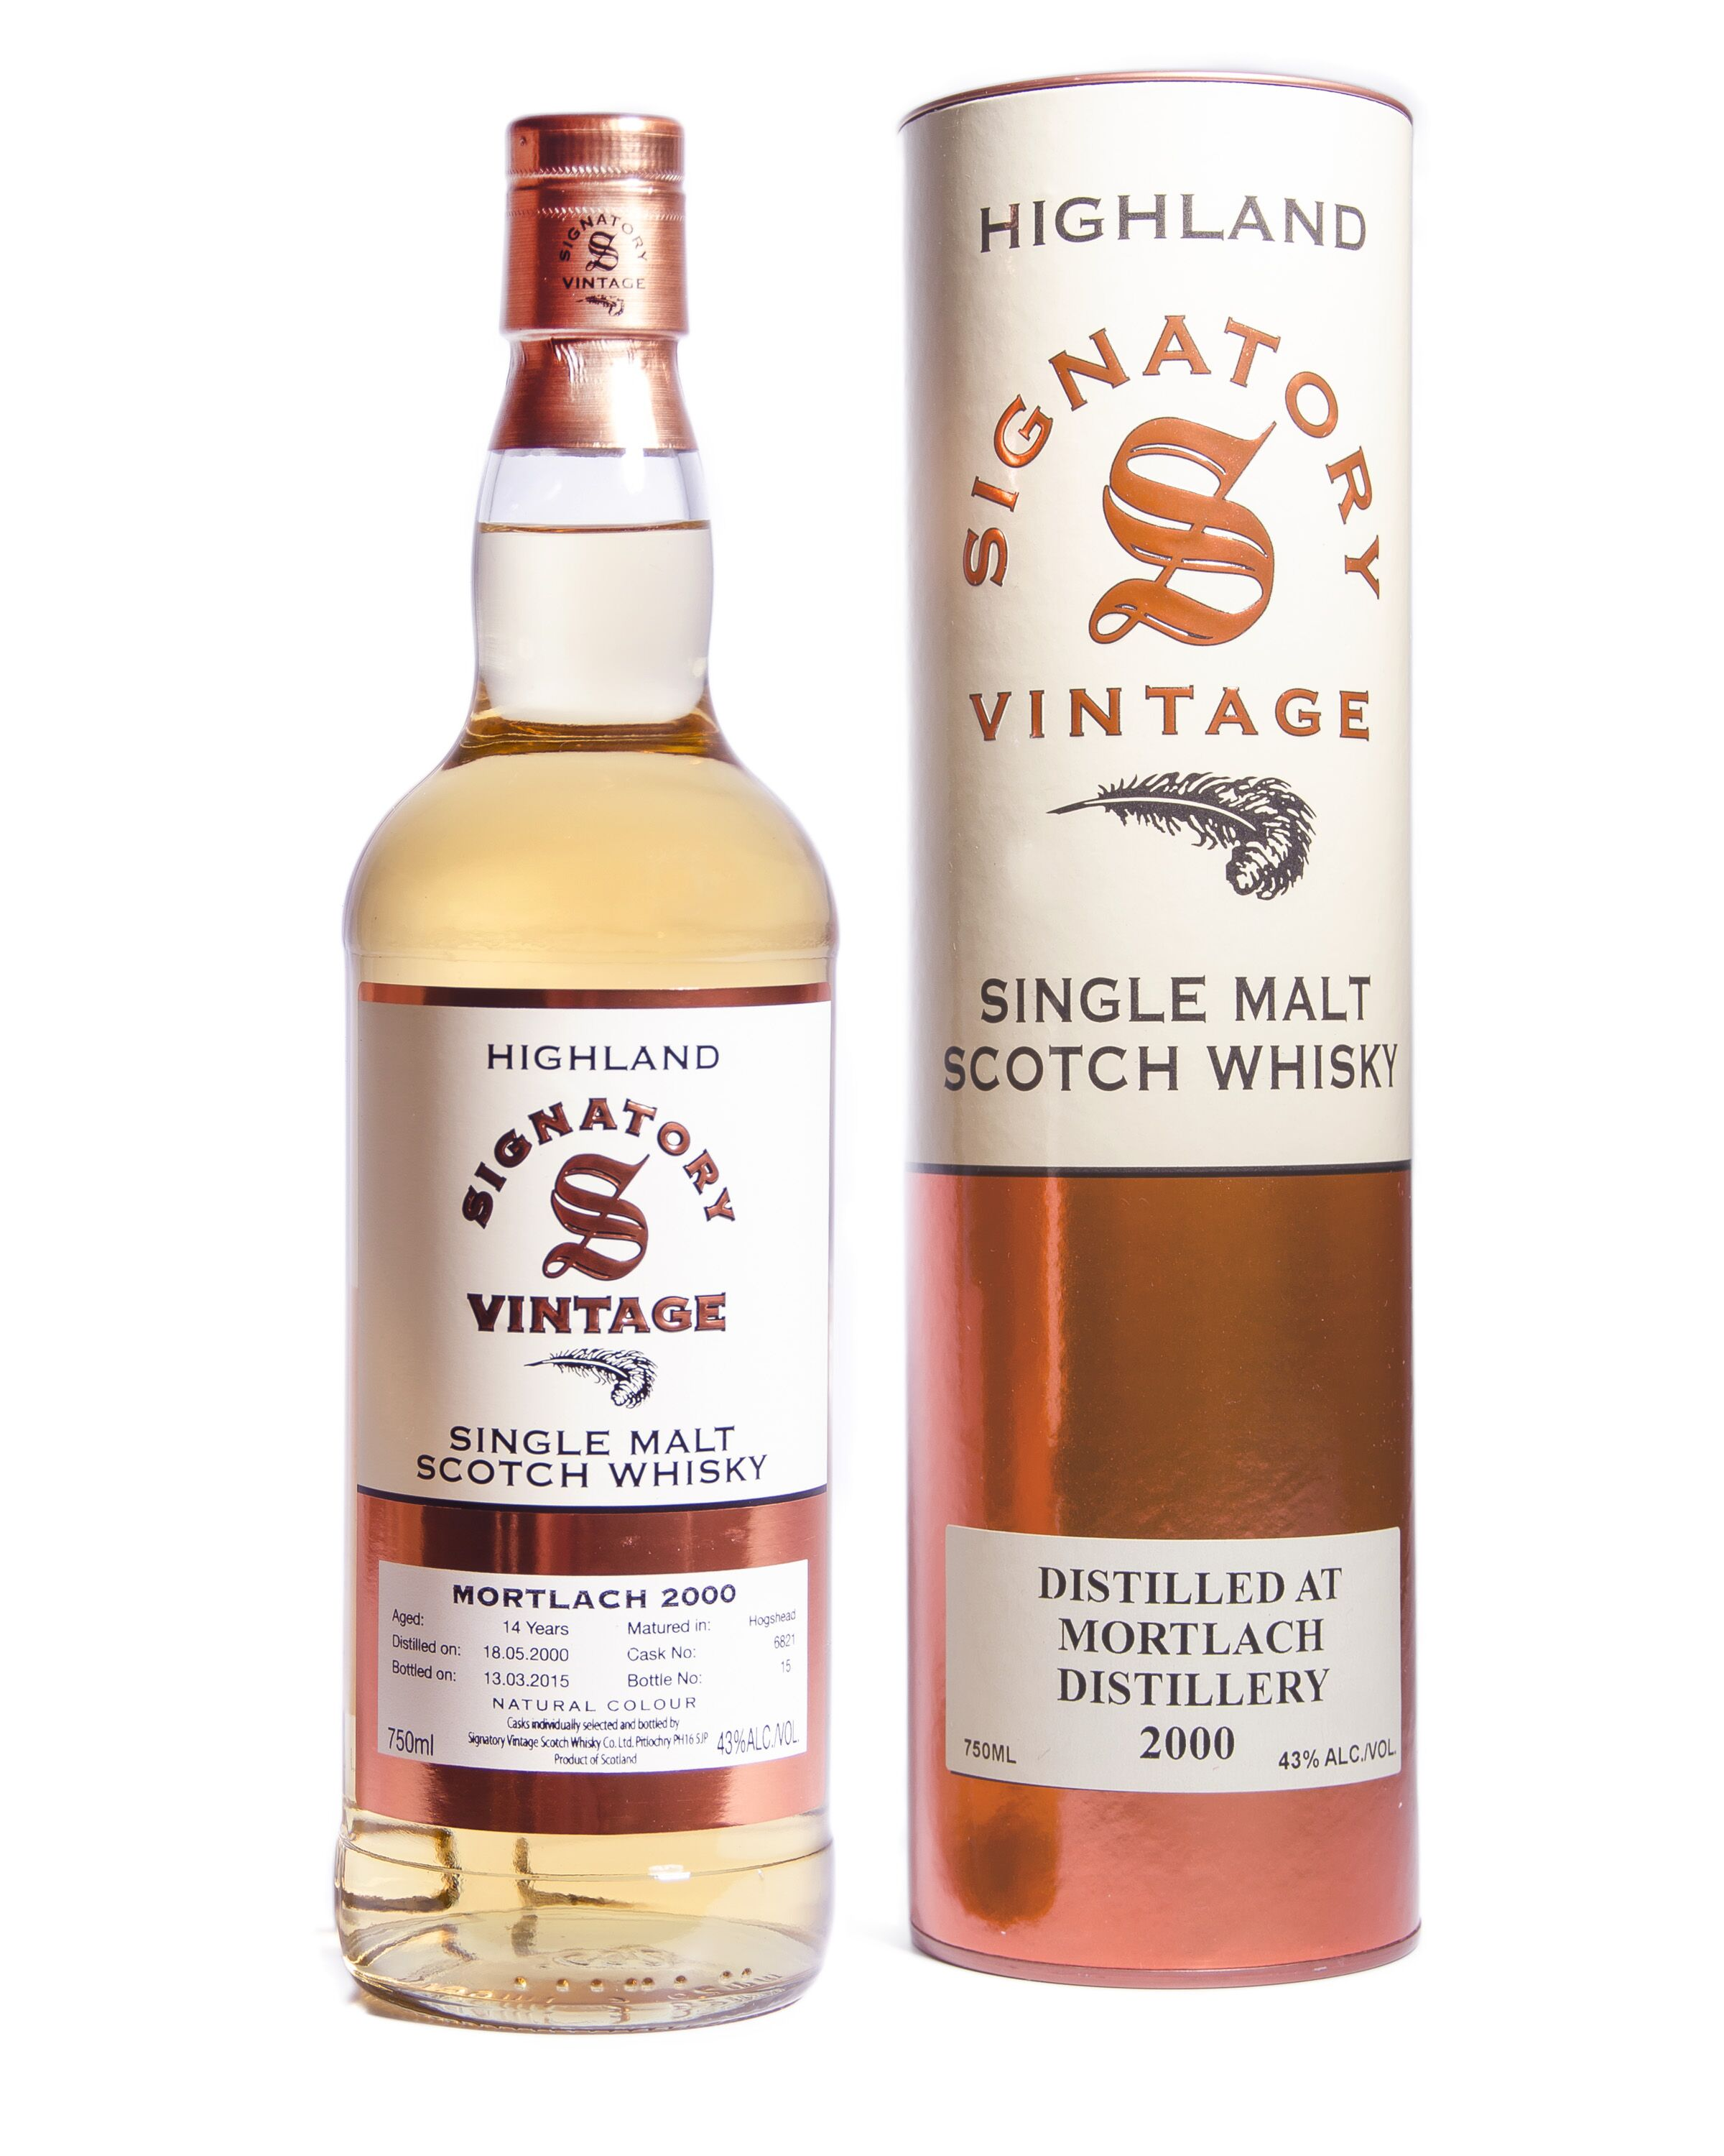

**AGED:** 14 years

**DISTILLED ON:** May 18, 2000

**BOTTLED ON:** March 13, 2015

**MATURED IN:** Hogshead

**CASK NO:** 6821

**BOTTLE NO:** of 15

_________________________________________

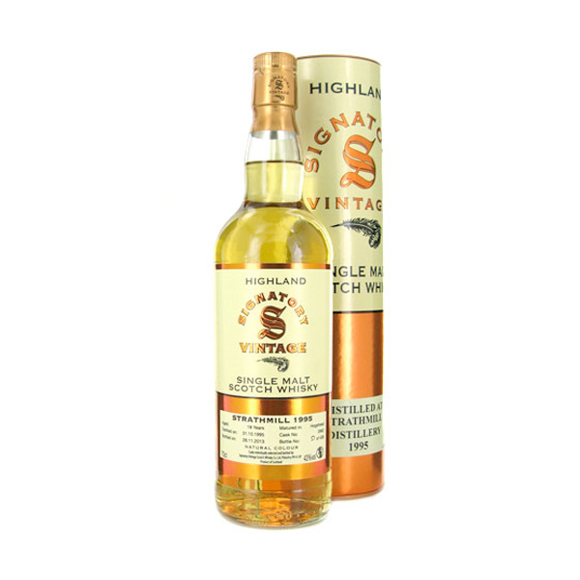

Mortlach prides itself on being Dufftown’s first legal distillery. It was founded in 1823 by James Findlater. Mortlach’s malts have the classic Speyside flavor, although the set-up is far from traditional. The distillery has three wash stills and three spirit stills, which can produce nearly 3 million liters a year.

# TASTE NOTES

**COLOR**: light golden straw

**NOSE:** cereal sweetness with warm barley

**TASTE**: apple blossoms, stewed fruits and a hint of Christmas punch. Later, cereal notes return with syrupy texture.

**FINISH**: long, with fruit and spices

C:\STOCKLAYOUTS\CURRENT PROJECTS\FN99807-PL\FN99807-IMG05.emf

www.SignatoryUSA.com

Imported by Total Beverage Solution

www.SignatoryScotch.com

IMPORTED BY TOTAL BEVERAGE SOLUTIONS