* 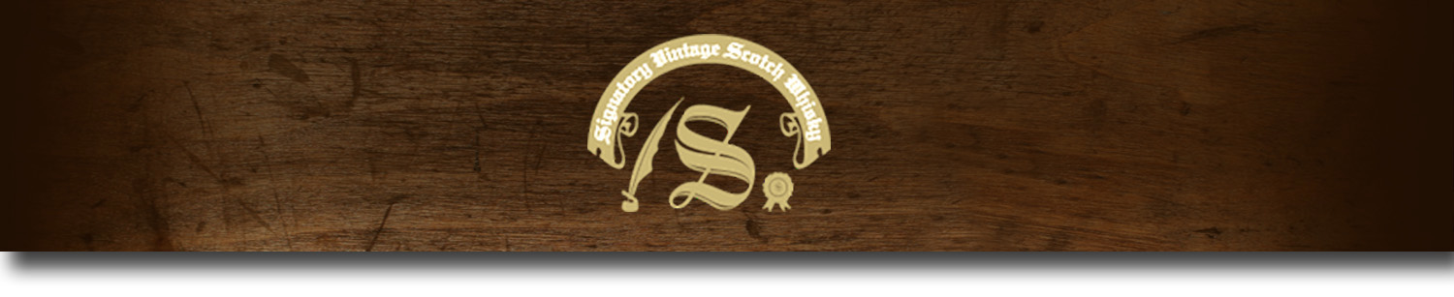Un-Chillfiltered Series -

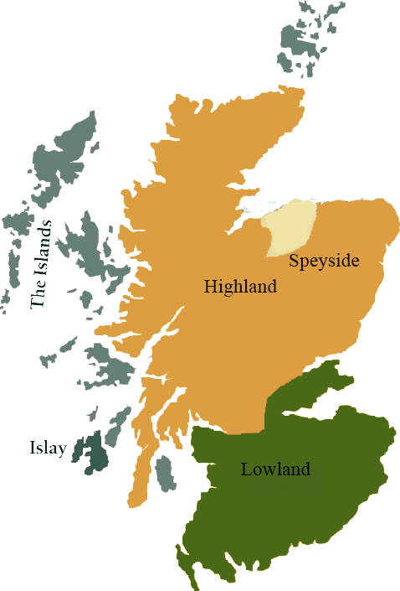*A comprehensive selection of natural strength whiskies, in individually numbered bottles, is available. This selection offers whiskies up to 35 years old, with rare malts being offered in a luxurious gift box with a certificate of authenticity.*

# Glenlivet 1996

SPEYSIDE REGION • SHERRY BUTT CASK

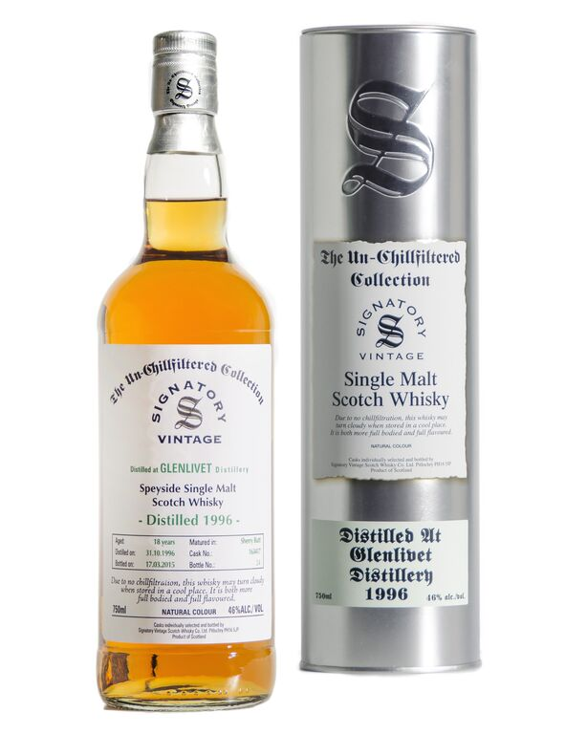

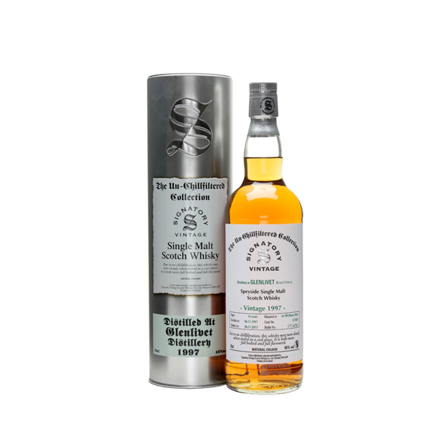

**AGED:** 18 years

**DISTILLED ON:** October 31, 1996

**BOTTLE ON:** March 17, 2015

**MATURED IN:** Sherry Butt

**CASK NO:** 163417

_________________________________________

The Glenlivet distillery is a distillery near Ballindalloch in Moray, Scotland that produces single malt Scotch whisky. It is the oldest legal distillery in the parish of Glenlivet, and the production place of the Scottish whisky of the same name. It is described in packaging and advertising as "The single malt that started it all". It was founded in 1824 and has operated almost continuously since

C:\STOCKLAYOUTS\CURRENT PROJECTS\FN99807-PL\FN99807-IMG05.emf

# TASTE NOTES

**COLOR**: golden wheat

**NOSE**: notes of chewy sultanas and sherried peels, barley sugars and toasty cereals with petals and apple blossom.

**TASTE**: full and rich, with notes of chewy, tannic oak. Also, manuka honey and walnut, with Cox’s apples and orange peels, cut herbs; fennel and spearmint.

**FINISH**: long and dry, with a spicy oak note.

Imported by Total Beverage Solution

www.SignatoryUSA.com

www.SignatoryScotch.com

IMPORTED BY TOTAL BEVERAGE SOLUTIONS