* 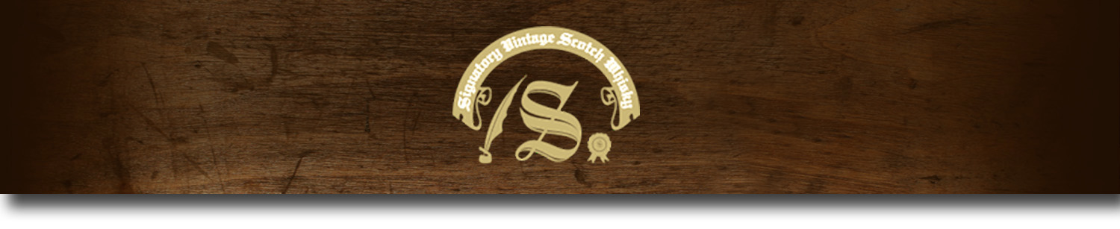Un-Chillfiltered Series -

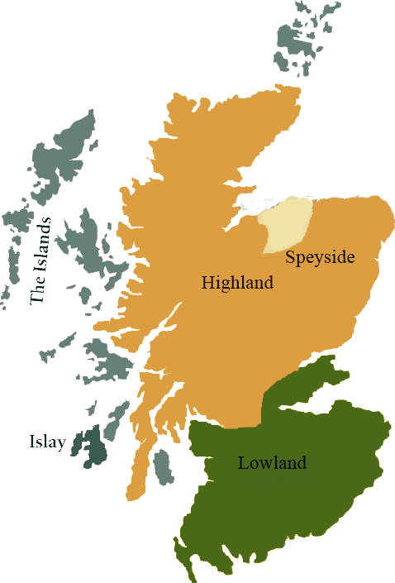*A comprehensive selection of natural strength whiskies, in individually numbered bottles, is available. This selection offers whiskies up to 35 years old, with rare malts being offered in a luxurious gift box with a certificate of authenticity.*

# Caol Ila 2003

ISLAY REGION • HOGSHEAD

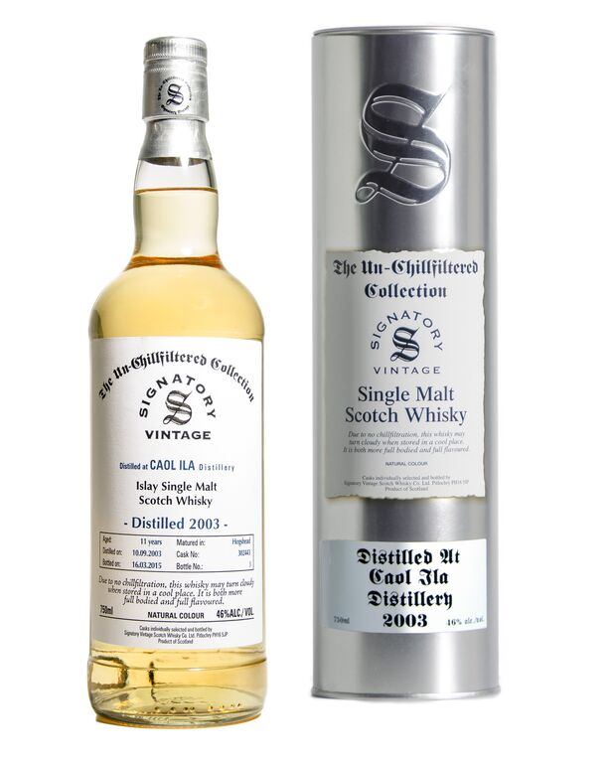

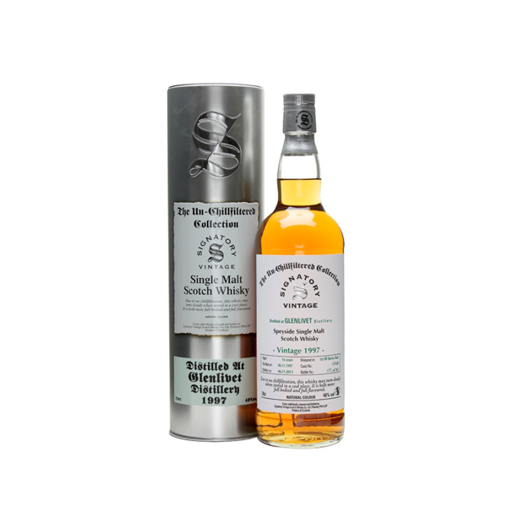

**AGED:** 11 years

**DISTILLED ON:** September 10, 2003

**BOTTLE ON:** March 16, 2015

**MATURED IN:** Hogshead

**CASK NO:** 302443

_________________________________________

Caol Ila, pronounced ‘cull-eela’, is the Gaelic name for the Sound of Islay, in reference to the distillery's location overlooking the strait between Islay and Jura. Built in 1846, Caol Ila is the largest of the eight working distilleries on the island of Islay.

# TASTE NOTES

**COLOR**: white wine

**NOSE**: cured meats, saltines and tropical fruits

**TASTE**: red apples, peat, and chocolate palate.

**FINISH**: touches of peanut butter, toasted bread, and nuts.

C:\STOCKLAYOUTS\CURRENT PROJECTS\FN99807-PL\FN99807-IMG05.emf

Imported by Total Beverage Solution

www.SignatoryUSA.com

www.SignatoryScotch.com

IMPORTED BY TOTAL BEVERAGE SOLUTIONS