* 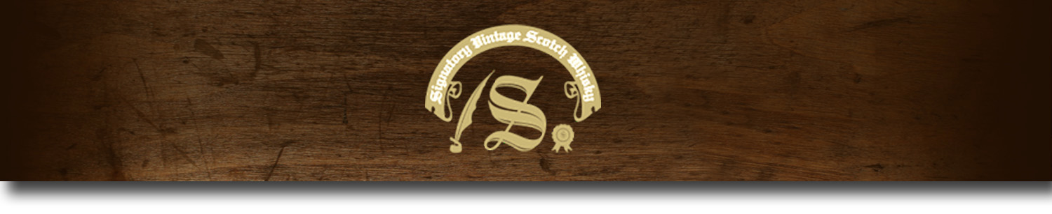Cask Strength Series -

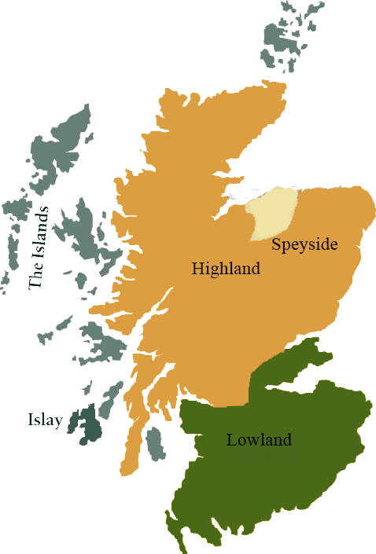*A comprehensive selection of natural strength whiskies, in individually numbered bottles, is available. This selection offers whiskies up to 35 years old, with rare malts being offered in a luxurious gift box with a certificate of authenticity.*

# Ben Nevis 1991

HIGHLAND REGION • SHERRY BUTT CASK

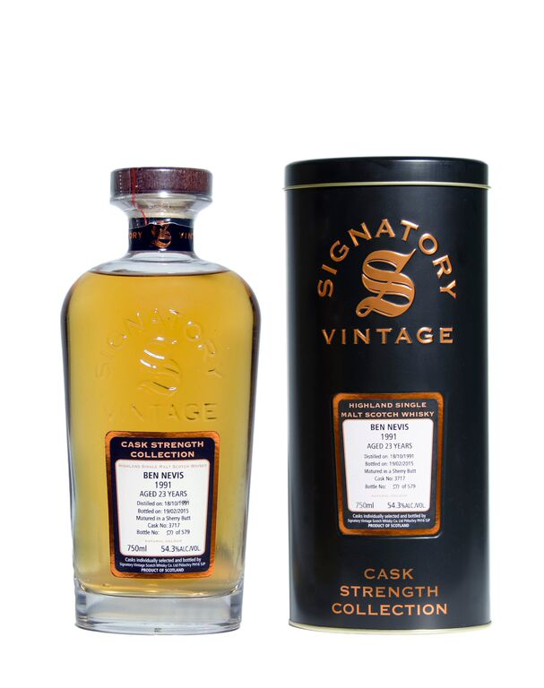

**AGED:** 23 years

**DISTILLED ON:** October 18, 1991

**BOTTLE ON:** February 19, 2015

**MATURED IN:** Sherry Butt

**CASK NO:** 3717

**BOTTLE NO:** of 579

_________________________________________

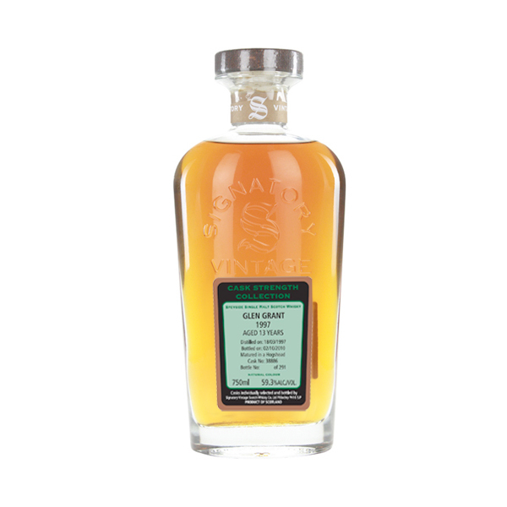

Named after the Scotland’s highest peak, Ben Nevis sits at the base of its namesake mountain in the country’s Western Highlands. The distillery was opened by John MacDonald in 1825, and was passed down within the family for generations. In the early twentieth century, the distillery came under combined ownership with the nearby Nevis Distillery, and today remains one of Scotland’s most renowned producers of cask-finishes, limited editions, and independently bottled malts.

C:\STOCKLAYOUTS\CURRENT PROJECTS\FN99807-PL\FN99807-IMG05.emf

www.SignatoryUSA.com

Imported by Total Beverage Solution

# TASTE NOTES

**COLOR**: light amber

**NOSE**: a hint of oranges, raisins, toffee and spices.

**TASTE**: lemon, oranges and raisins.

**FINISH**: fruity and warm, dry with spice late on.

www.SignatoryScotch.com

IMPORTED BY TOTAL BEVERAGE SOLUTIONS