* 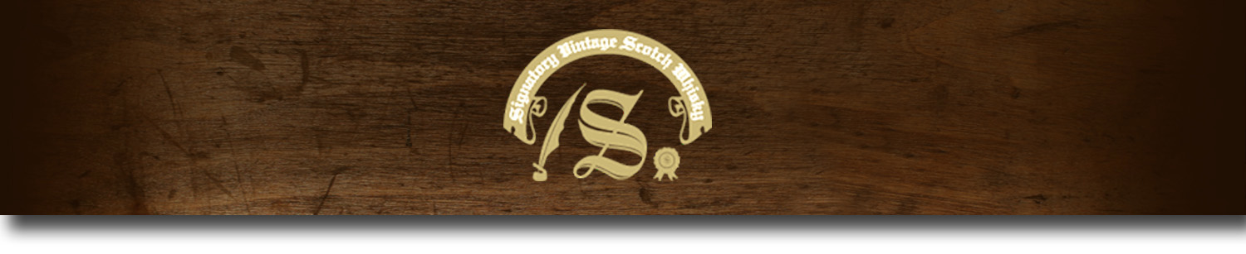Cask Strength Series -

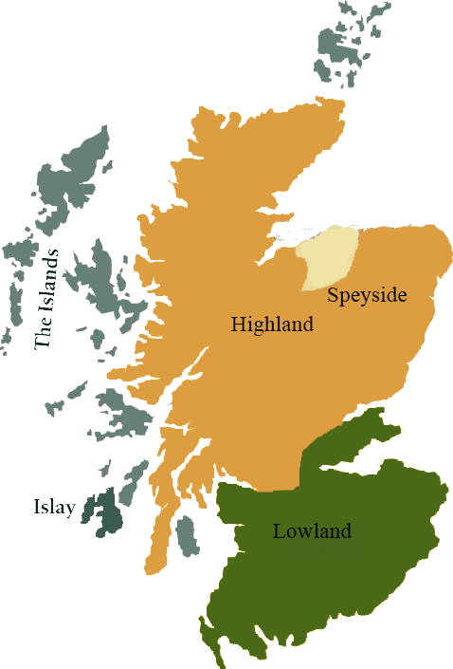*A comprehensive selection of natural strength whiskies, in individually numbered bottles, is available. This selection offers whiskies up to 35 years old, with rare malts being offered in a luxurious gift box with a certificate of authenticity.*

# Jura (Peated) 1989

INNER HEBRIDES REGION • BOURBON BARREL CASK

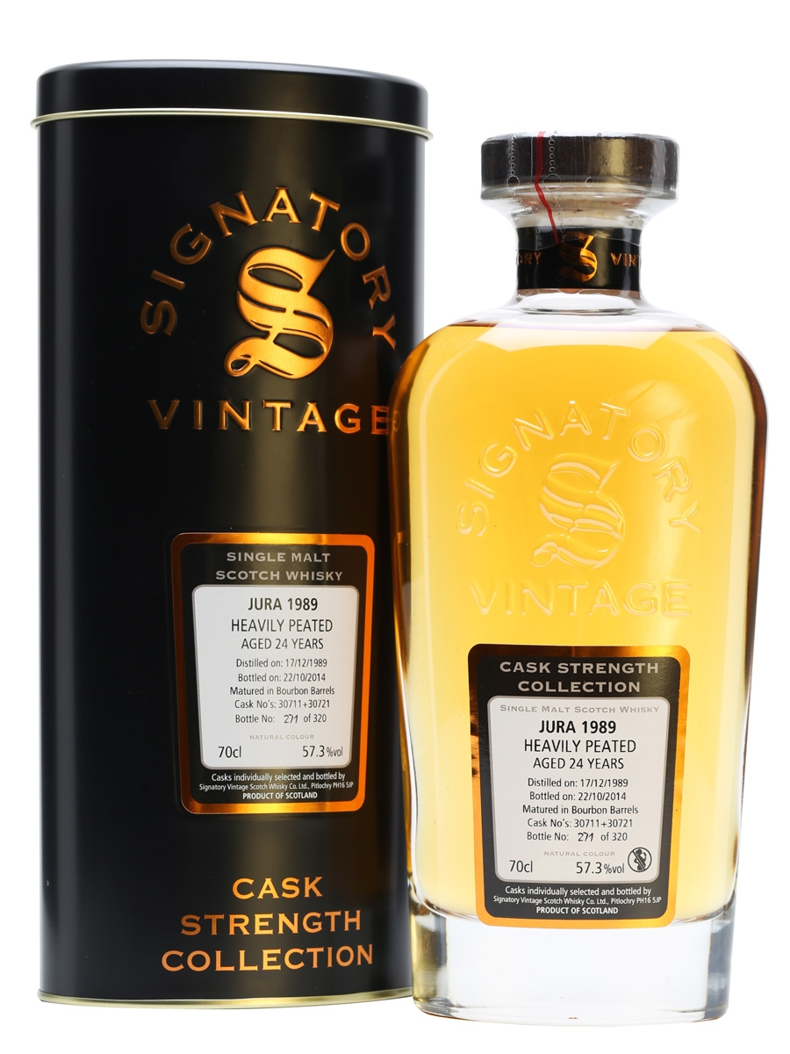

**AGED:** 24 years

**DISTILLED ON:** December 17, 1989

**BOTTLE ON:** September 17, 2014

**MATURED IN:** Bourbon Barrel

**CASK NO:** 30416

**BOTTLE NO:** of 158

_________________________________________

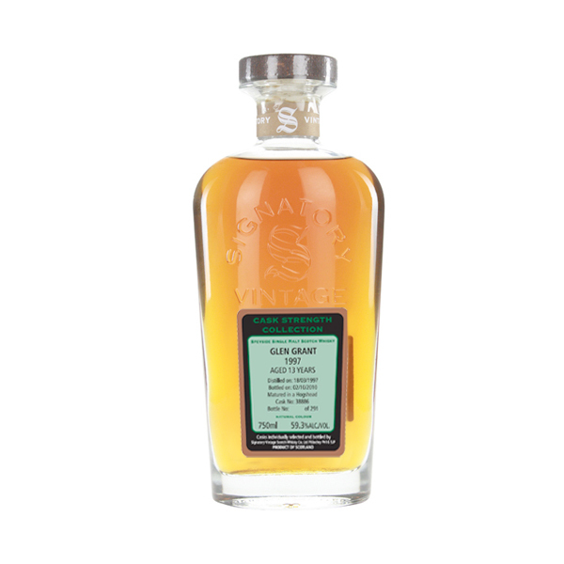

Located off Scotland's western coast on the Isle of Jura, the island's only distillery opened in 1810. After a massive renovation in the mid-1900s, the distillery was reopened in 1963 in hopes to boost the island's economy.

# TASTE NOTES

**COLOR**: amber

**NOSE**: Sooty notes, wet newspaper, along with a lot of coastal notes, olive juice, kelp, a little iodine, complemented by soft earthy notes and grass, burnt heather, and ginger. After a while creamier notes emerge, like ripe gooseberries and strawberries, and toffee.

**TASTE**: Oily, salty, and definitely peatier than the nose suggested. Flavors include grapefruit and softly bitter (burnt) herbs, sharp brine, smoked, salted fish, and oysters. Some sweet lemon and vague white fruits present underneath.

**FINISH**: long, quite sharp and briny again, with grasses, herbs and liquor ice.

www.SignatoryUSA.com

C:\STOCKLAYOUTS\CURRENT PROJECTS\FN99807-PL\FN99807-IMG05.emf

Imported by Total Beverage Solutions

www.SignatoryScotch.com

IMPORTED BY TOTAL BEVERAGE SOLUTIONS