* 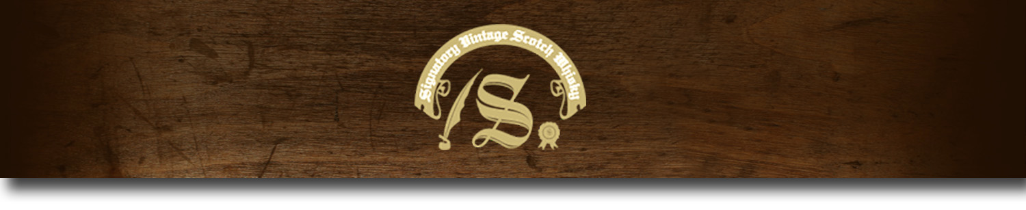Cask Strength Series -

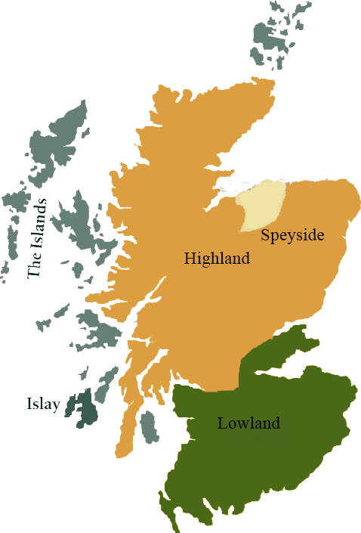*A comprehensive selection of natural strength whiskies, in individually numbered bottles, is available. This selection offers whiskies up to 35 years old, with rare malts being offered in a luxurious gift box with a certificate of authenticity.*

# Glenturret 1986

HIGHLAND REGION • HOGSHEAD CASK

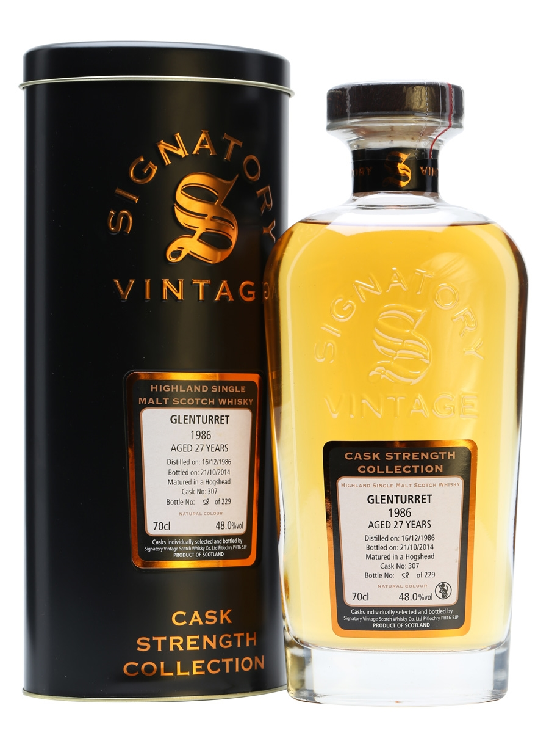

**AGED:** 27 years

**DISTILLED ON:** December 16, 1986

**BOTTLE ON:** September 17, 2014

**MATURED IN:** Hogshead

**CASK NO:** 306

**BOTTLE NO:** of 237

_________________________________________

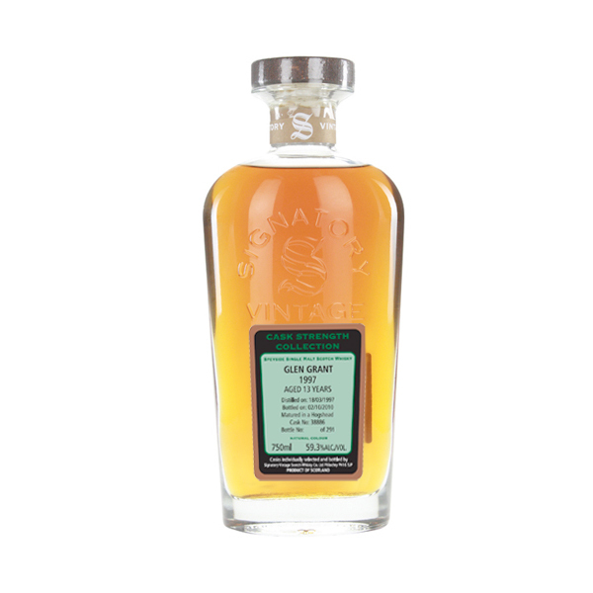

Dating back to 1775, Glenturret is the oldest active distillery in Scotland.Formerly known as Hosh, the distillery was renamed in 1875. The distillery was closed and dismantled in the 1920s upon Prohibition's enactment, remaining closed until the late 1950s. Glenturret's claim to fame is it's association with the Edrington Group's Grouse blend, and today is one of the most frequested distillery's in the industy.

# TASTE NOTES

**COLOR**: pale gold

**NOSE**: decadent toffee popcorn, milk chocolate and apple all appear at first, followed by soft hints of sandalwood.

**TASTE**: fragrant vanilla blended with caramel. Golden syrup drips in, rich and sugary.

**FINISH**: soft ginger spices shake up the finish very well.

C:\STOCKLAYOUTS\CURRENT PROJECTS\FN99807-PL\FN99807-IMG05.emf

www.SignatoryUSA.com

Imported by Total Beverage Solutions

www.SignatoryScotch.com

IMPORTED BY TOTAL BEVERAGE SOLUTIONS