* 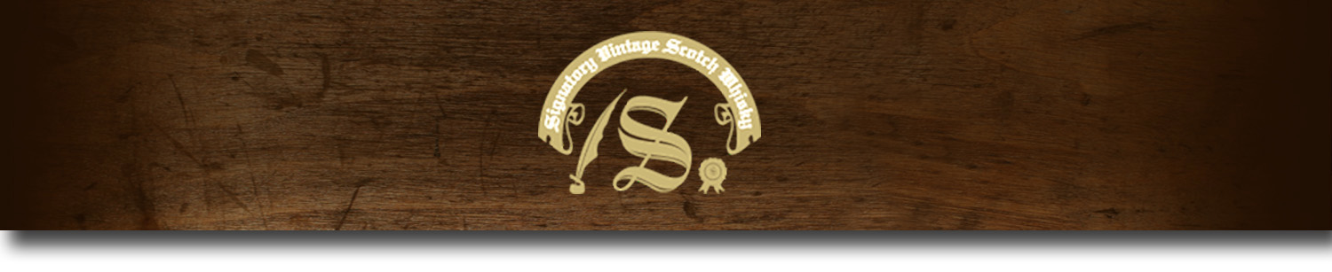Cask Strength Series -

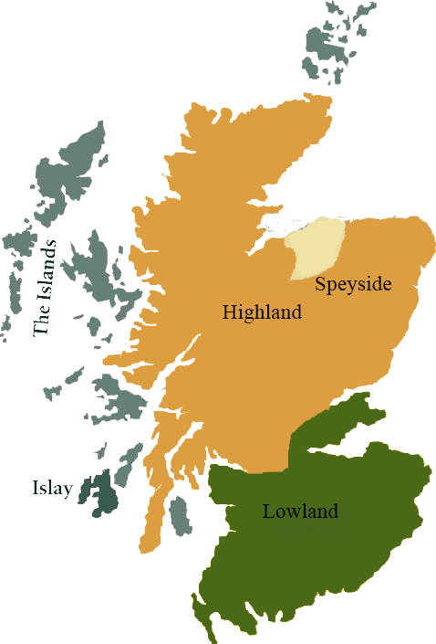*A comprehensive selection of natural strength whiskies, in individually numbered bottles, is available. This selection offers whiskies up to 35 years old, with rare malts being offered in a luxurious gift box with a certificate of authenticity.*

# Glenlivet 1981

SPEYSIDE REGION • REFILL SHERRY HOGSHEAD CASK

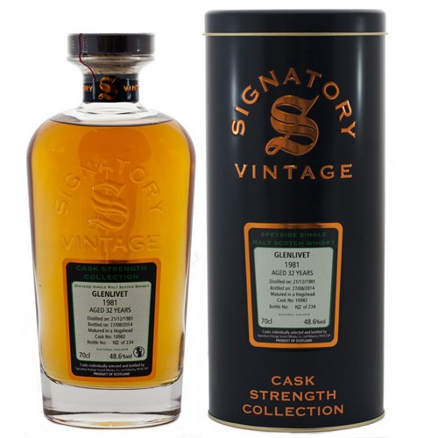

**AGED:** 32 years

**DISTILLED ON:** November 5, 1981

**BOTTLE ON:** September 17, 2014

**MATURED IN:** Refill SherryHogshead

**CASK NO:** 9453

**BOTTLE NO:** of 150

_________________________________________

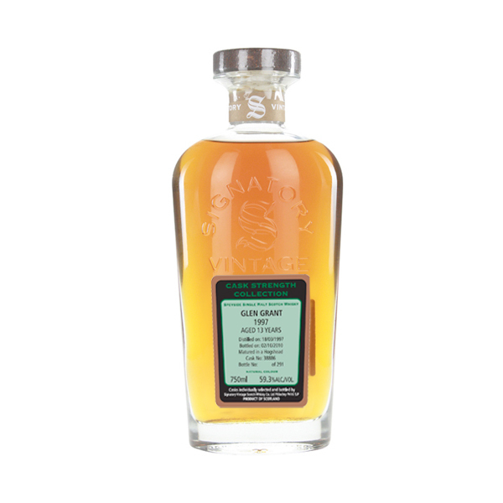

The Glenlivet distillery is a distillery near Ballindalloch in Moray, Scotland that produces single malt Scotch whisky. It is the oldest legal distillery in the parish of Glenlivet, and the production place of the Scottish whisky of the same name. It is described in packaging and advertising as "The single malt that started it all". It was founded in 1824 and has operated almost continuously since. The Glenlivet brand is the biggest selling single malt whiskey in the United States and the second biggest selling single malt brand globally.

C:\STOCKLAYOUTS\CURRENT PROJECTS\FN99807-PL\FN99807-IMG05.emf

www.SignatoryUSA.com

Imported by Total Beverage Solutions

# TASTE NOTES

**COLOR**: amber

**NOSE**: ‘old’ tobacco, leather polish, bitter chocolate, walnut liqueur, herbal teas, old dry sherry.

**TASTE**: Some leathery and spicy fruits, green oranges, mint lozenges, plenty of walnuts, bay leaves, and some juniper.

**FINISH**: long, with herbs and fresh walnuts.

www.SignatoryScotch.com

IMPORTED BY TOTAL BEVERAGE SOLUTIONS