* 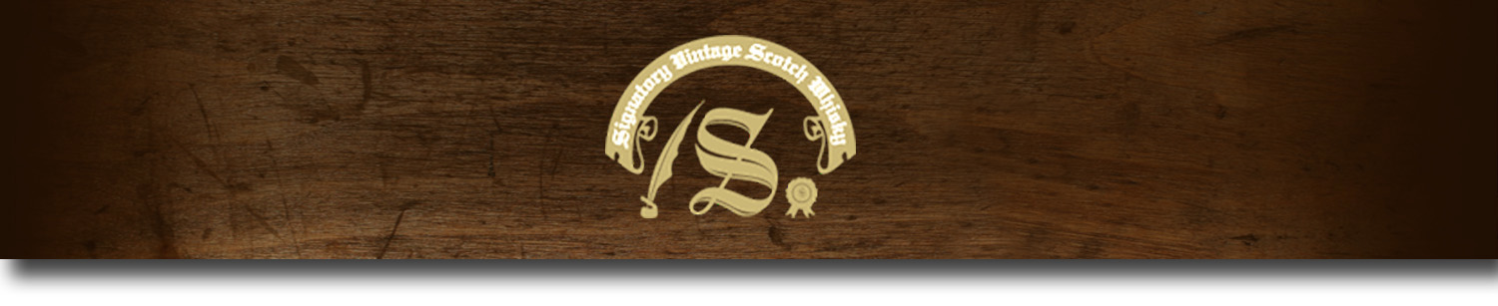86 Proof Series -

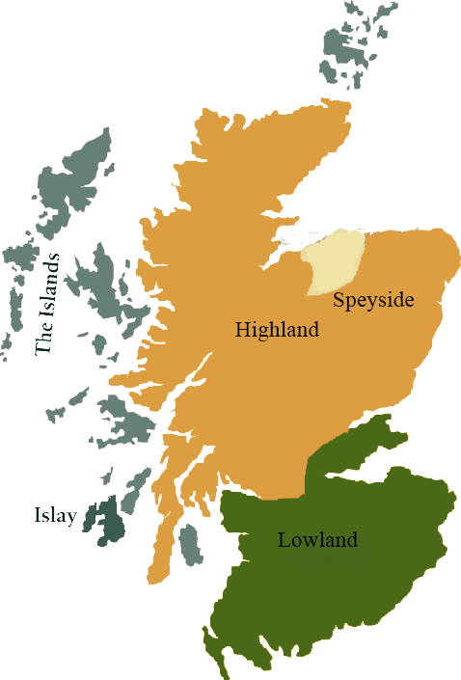*This collection offers a comprehensive range of single malts, up to 20 years old, from each of Scotland’s distilling regions. All are bottled at 86 proof, and are offered in color coordinated presentation tins with matching labels, identifying the region of distillation.*

# Glenburgie 1995

HIGHLAND REGION • HOGSHEAD CASK

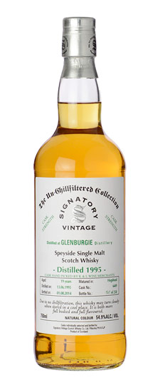

**AGED:** 19 years

**DISTILLED ON:** June 13, 1995

**BOTTLED ON:** July 28, 2014

**MATURED IN:** Hogshead

**CASK NO:** 6459

**BOTTLE NO:** of 352

_________________________________________

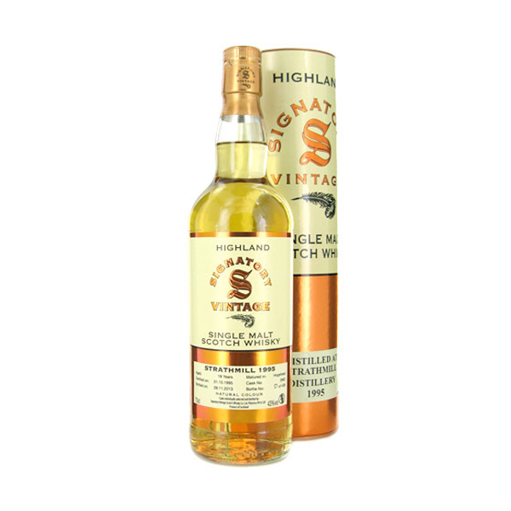

Designed by famous architect Charles Chree Doig as the Kilnflat Distillery in 1810, Glenburgie is one of Scotland's oldest distilleries. The distillery renowned for its role in producing malts for the Ballantine blend, Glenburgie has been essential to creating premium blends. After Pernod Ricard bought the distillery in 2005, the distillery increased its production to over 4 million liters annually, making it one of the largest of the Pernod Chivas Bros. group's distilleries.

C:\STOCKLAYOUTS\CURRENT PROJECTS\FN99807-PL\FN99807-IMG05.emf

www.SignatoryUSA.com

Imported by Total Beverage Solution

# TASTE NOTES

**COLOR**: amber

**NOSE**: toasted oak & candied citrus

**TASTE**: supple vanilla, citrus

**FINISH**: spicy, fruit-forward

www.SignatoryScotch.com

IMPORTED BY TOTAL BEVERAGE SOLUTIONS