* 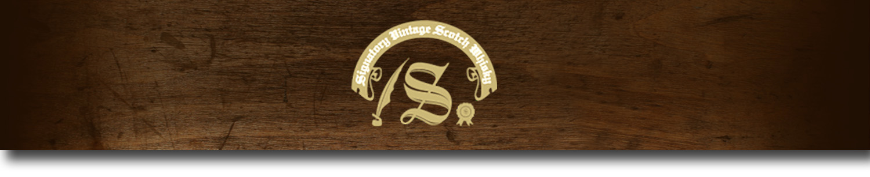Un-Chillfiltered Series -

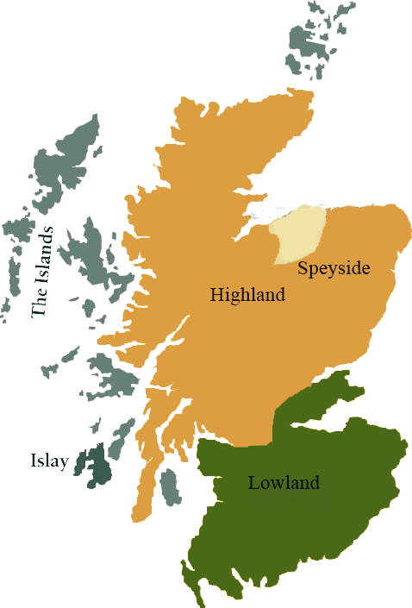*A comprehensive selection of natural strength whiskies, in individually numbered bottles, is available. This selection offers whiskies up to 35 years old, with rare malts being offered in a luxurious gift box with a certificate of authenticity.*

# Glen Rothes 1999

SPEYSIDE REGION • HOGSHEAD

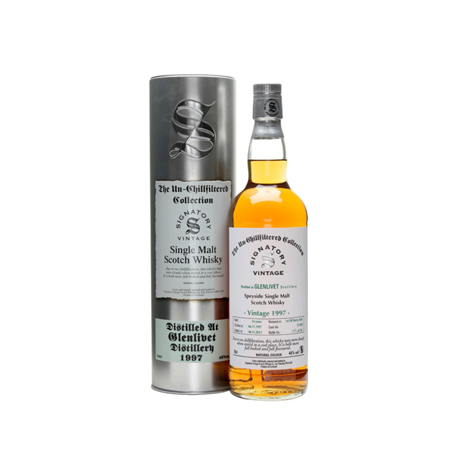

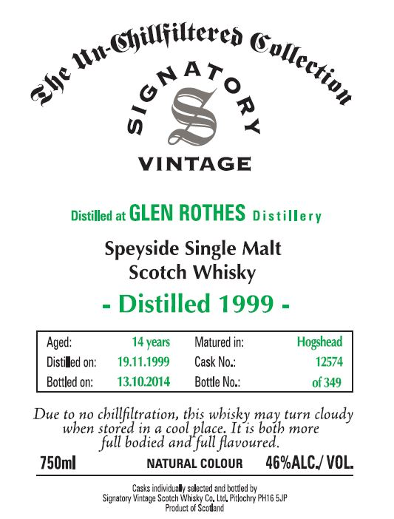

**AGED:** 14 years

**DISTILLED ON:** November 19, 1999

**BOTTLE ON:** October 13, 2014

**MATURED IN:** Hogshead

**CASK NO:** 12574

**BOTTLE NO:** of 349

_________________________________________

The Glenrothes distillery has been producing malt whiskey since 1879. The distillery's unique bottling process focuses on the vintage of the malt, not the age, to ensure quality distilling and careful planning. Carefully selected barrels, barleys, and spring water ensure Glenrothes malts are of the highest quality and flavor..

C:\STOCKLAYOUTS\CURRENT PROJECTS\FN99807-PL\FN99807-IMG05.emf

# TASTE NOTES

**COLOR**: goldenrod

**NOSE**: bananas, apples, and raisins.

**TASTE**: orange, raisins, sherry with ginger notes.

**FINISH**: orange zest, ginger, figs and raisins.

Imported by Total Beverage Solution

www.SignatoryUSA.com

www.SignatoryScotch.com

IMPORTED BY TOTAL BEVERAGE SOLUTIONS