* 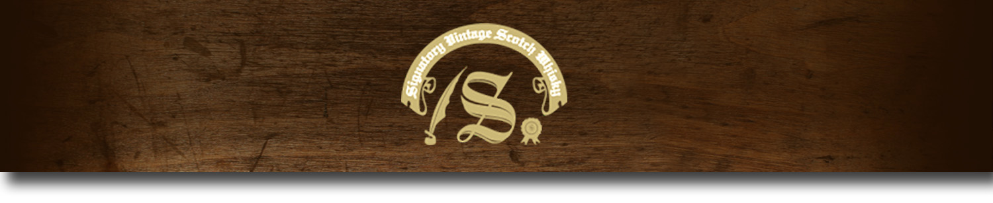86 Proof Series -

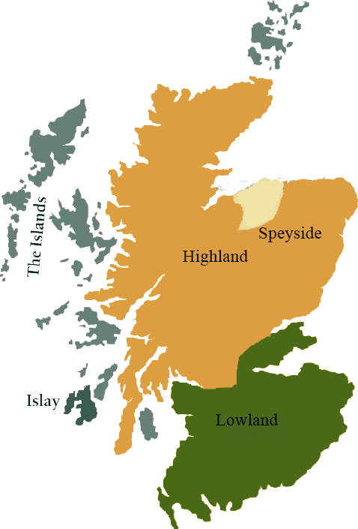*This collection offers a comprehensive range of single malts, up to 20 years old, from each of Scotland’s distilling regions. All are bottled at 86 proof, and are offered in color coordinated presentation tins with matching labels, identifying the region of distillation.*

# Fettercairn 1996

HIGHLAND REGION • HOGSHEAD CASK

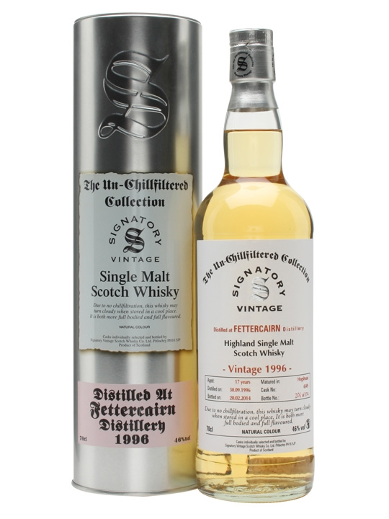

**AGED:** 17 years

**DISTILLED ON:** September 30, 1996

**BOTTLED ON:** July 28, 2014

**MATURED IN:** Hogshead

**CASK NO:** 4350

**BOTTLE NO:** of 342

_________________________________________

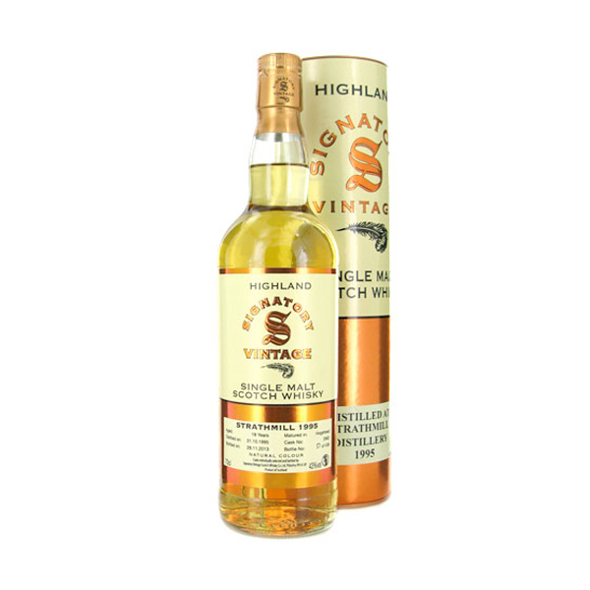

Sir Alexander Ramsay opened Fettercairn in a refurbished corn mill in 1824. The distillery, which was only the second legalized distillery under the Excise Act, is located in Cairngorm Mountains in Scotland's Eastern Highlands. Now owned by Whyte & Mackay, the distillery blends light, balanced whiskies.

C:\STOCKLAYOUTS\CURRENT PROJECTS\FN99807-PL\FN99807-IMG05.emf

www.SignatoryUSA.com

# TASTE NOTES

**COLOR**: amber

**NOSE**: malt extract. Sesame thins and thick, rich turbinado sugar.

**TASTE**: sweet, green apple with caramelized brown sugar.

**FINISH**: tarte tatin fades into crème brûlee, with a suggestion of old oak.

Imported by Total Beverage Solution

www.SignatoryScotch.com

IMPORTED BY TOTAL BEVERAGE SOLUTIONS