* 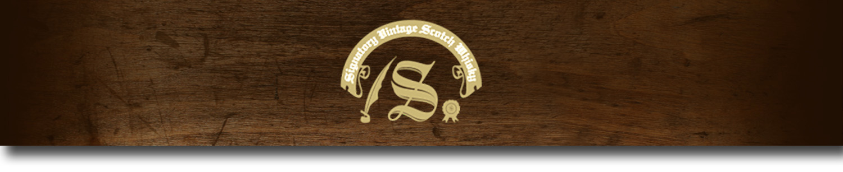86 Proof Series -

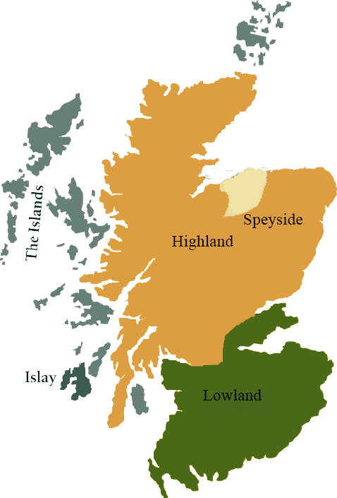*This collection offers a comprehensive range of single malts, up to 20 years old, from each of Scotland’s distilling regions. All are bottled at 86 proof, and are offered in color coordinated presentation tins with matching labels, identifying the region of distillation.*

# Allt-a-Bhainne 1995

HIGHLAND REGION • HOGSHEAD CASK

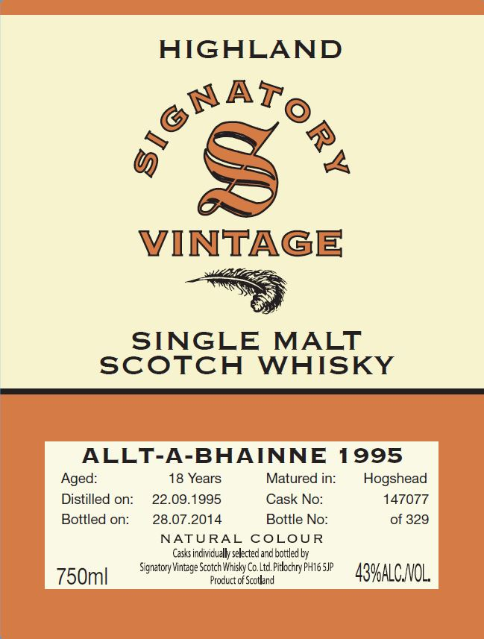

**AGED:** 18 years

**DISTILLED ON:** September 22, 1995

**BOTTLED ON:** July 28, 2014

**MATURED IN:** Hogshead

**CASK NO:** 147077

**BOTTLE NO:** of 329

_________________________________________

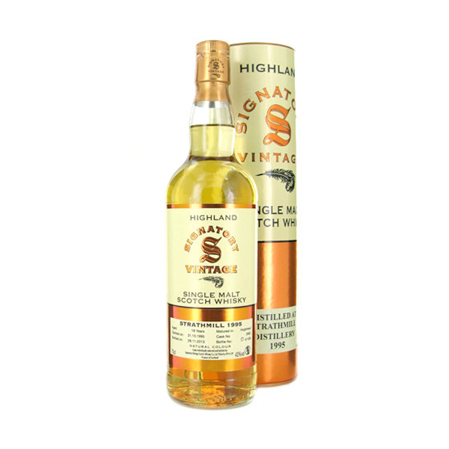

Found in the Southern part of Scotland's Speyside region in 1975, Allt-A-Bhainne supplies malt whiskey for Chivas blends. Created as a subsidiary of Seagram's, the small distillery creates malts through a simplified distilling process that features barrels manned by a single staff member. After a brief hiatus, the distillery was re-opened in 2005 due to high demand for the nuanced, high-quality spirits.

C:\STOCKLAYOUTS\CURRENT PROJECTS\FN99807-PL\FN99807-IMG05.emf

www.SignatoryUSA.com

Imported by Total Beverage Solution

# TASTE NOTES

**COLOR**: pale lemony gold

**NOSE**: pear, apple peels, orange blossom, pepper,

zest and honey

**TASTE**: tangy and fruity, with notes of peppermint, stewed

apples, cinnamon and dark honey.

**FINISH**: bittersweet, with notes of sawdust and cut hay.

www.SignatoryScotch.com

IMPORTED BY TOTAL BEVERAGE SOLUTIONS