* 86 Proof Series -

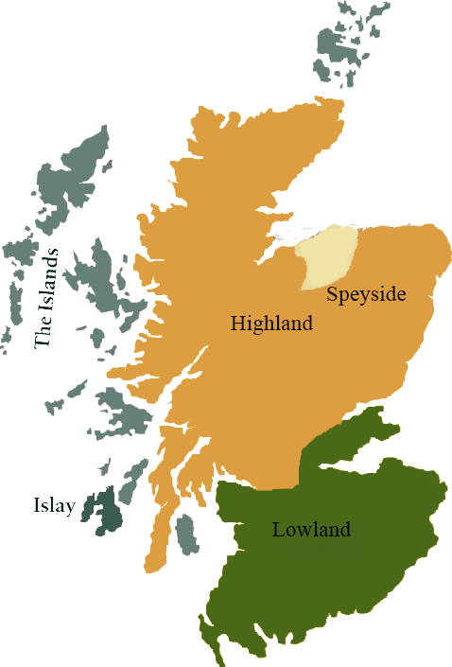*This collection offers a comprehensive range of single malts, up to 20 years old, from each of the distilling areas of Scotland. All bottled at 86 proof, and are offered in color coordinated presentation tins with matching labels, identifying the regions of distillation.*

# Strathmill 1995

HIGHLAND REGION • HOGSHEAD CASK

**AGED:** 16 years

**DISTILLED ON:** August 1995

**BOTTLE ON:** July 2012

**MATURED IN:** Hogshead

**CASK NO:** 1827

**BOTTLE NO:** of 398

_________________________________________

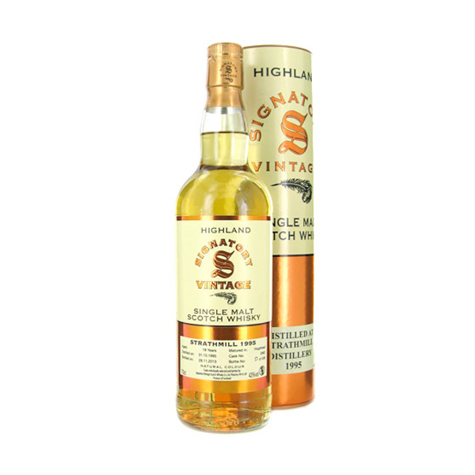

Strathmill was converted into a distillery in 1891, from the Strathisla corn and flour mill, in the village of Keith. The distillery was officially known as Glenisla-Glenlivet distillery until it was bought by W & A Gilbey who also owned Glen Spey. The distillery was incorporated into IDV in 1962 and has subsequently come under the ownership of Guinness UDV.

C:\STOCKLAYOUTS\CURRENT PROJECTS\FN99807-PL\FN99807-IMG05.emf

# TASTE NOTES

**COLOR**: Pale Gold

**NOSE**: coloured pencil shavings, mashed banana, sweet roses, pineapple and ‘Nice’ [coconut] biscuits

**TASTE**: green banana, pineapple chunks, sweets, warming coconut white rum, green/virgin oak, tropical fruits, mild and smooth and cocktail-like

**FINISH**: Drying and sharp/spicy, tannic and of medium length

Imported by Total Beverage Solution

www.SignatoryScotch.com

www.SignatoryScotch.com

IMPORTED BY TOTAL BEVERAGE SOLUTIONS