* 86 Proof Series -

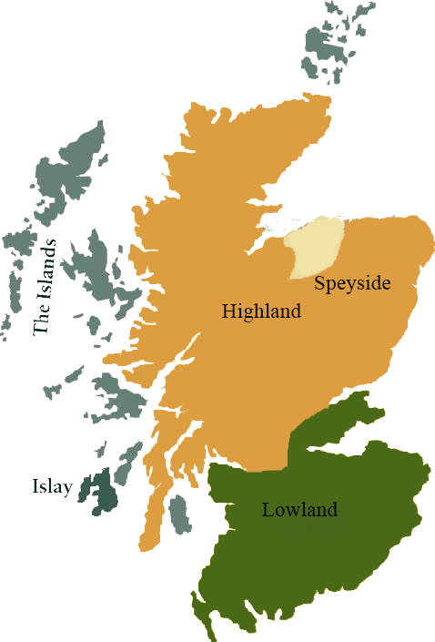*This collection offers a comprehensive range of single malts, up to 20 years old, from each of the distilling areas of Scotland. All bottled at 86 proof, and are offered in color coordinated presentation tins with matching labels, identifying the regions of distillation.*

# Linkwood 1995

HIGHLAND REGION • HOGSHEAD CASK

**AGED:** 18 years

**DISTILLED ON:** January 1995

**BOTTLE ON:** January 2014

**MATURED IN:** Hogshead

**CASK NO:** 658

**BOTTLE NO:** of 359

_________________________________________

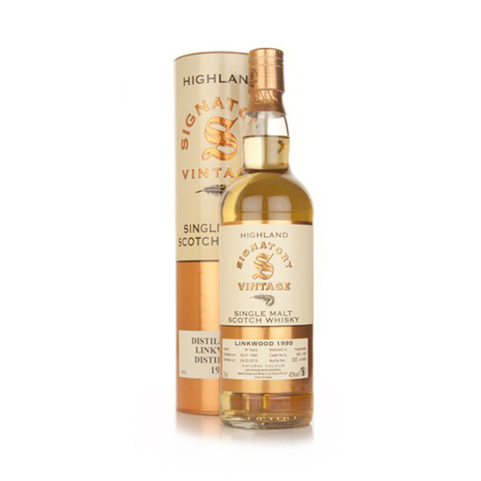

The distillery takes its name from the nearby Brown family home, the Linkwood house. James Walker & Co. ran the distillery from 1842 until 1868 when Peter Brown died and his son, William, succeeded him. In 1872 William completely rebuilt the distillery. In 1932 Linkwood came under the ownership of SMD and subsequently Diageo.

# TASTE NOTES

**COLOR**: light straw

**NOSE**: Apples and Vanilla

**TASTE**: Light and fruity

**FINISH**: Refreshing and tasty

C:\STOCKLAYOUTS\CURRENT PROJECTS\FN99807-PL\FN99807-IMG05.emf

Imported by Total Beverage Solution

www.SignatoryScotch.com

www.SignatoryScotch.com

IMPORTED BY TOTAL BEVERAGE SOLUTIONS