* Un-Chillfiltered Series -

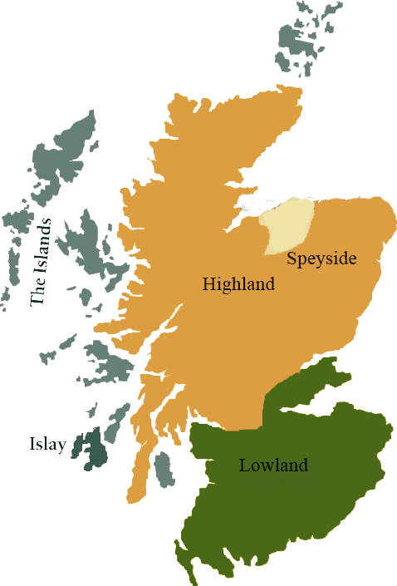*A comprehensive selection of natural strength whiskies, in individually numbered bottles, is available.This selection offers whiskies up to 35 years old, with rare malts being offered in a luxurious gift box with a certificate of authenticity.*

# Imperial 1995

SPEYSIDE REGION • HOGSHEAD CASK

**AGED:** 18 years

**DISTILLED ON:** August 1995

**BOTTLE ON:** January 2014

**MATURED IN:** Hogshead

**CASK NO:** 50145

**BOTTLE NO:** of 365

_________________________________________

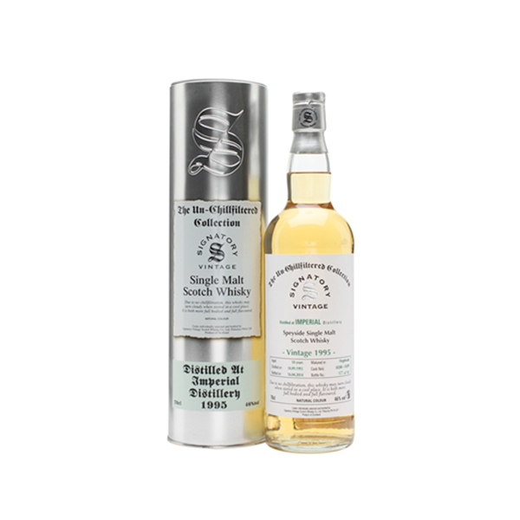

The Imperial Distillery was a producer of single malt Scotch whisky located in Carron, Speyside operating sporadically between 1897 and 1998. The distillery was demolished in 2013. Throughout its lifetime the production of Imperial was almost exclusively used for blends, notably Teacher's, Old Smuggler, Long John and Ballantine's.

www.SignatoryScotch.com

Imported by Total Beverage Solution

# TASTE NOTES

**COLOR**: Light Golden

**NOSE**: Sweet porridge oats and notes of beeswax. Honey, allspice and a little apple peel.

**TASTE**: Fruity palate, with all kinds of cereal sweetness. A little malt, liquorice and hints of gingernut biscuits.

**FINISH**: Orange zest and beeswax.

C:\STOCKLAYOUTS\CURRENT PROJECTS\FN99807-PL\FN99807-IMG05.emf

www.SignatoryScotch.com

IMPORTED BY TOTAL BEVERAGE SOLUTIONS