* 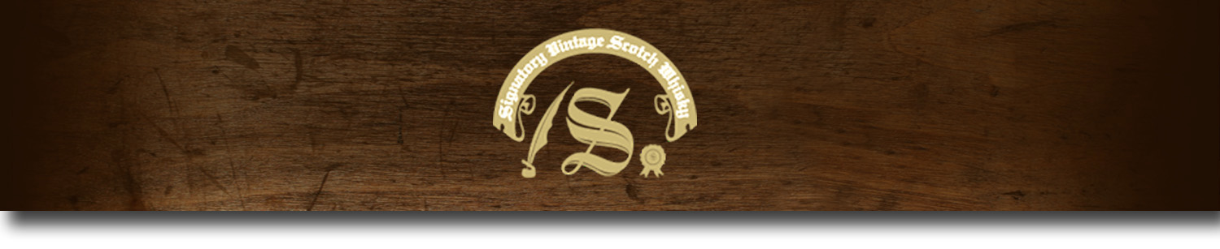Cask Strength Series -

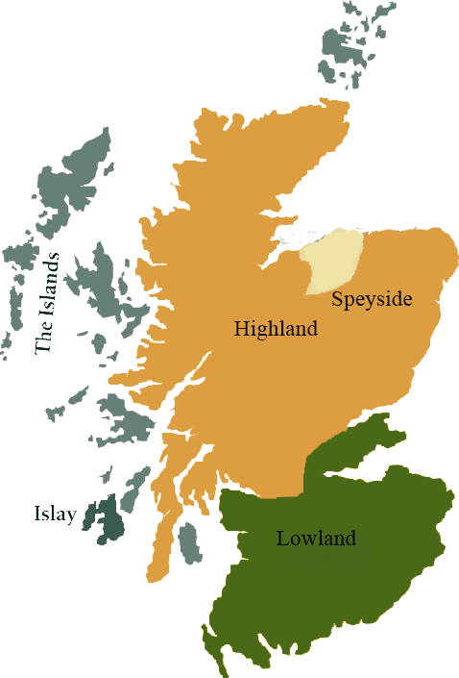*A comprehensive selection of natural strength whiskies, in individually numbered bottles, is available.This selection offers whiskies up to 35 years old, with rare malts being offered in a luxurious gift box with a certificate of authenticity.*

# Glen Grant 1997

SPEYSIDE REGION • HOGSHEAD CASK

**AGED:** 13 years

**DISTILLED ON:** March 1997

**BOTTLE ON:** February 2010

**MATURED IN:** Hogshead

**CASK NO:** 38886

**BOTTLE NO:** of 291

_________________________________________

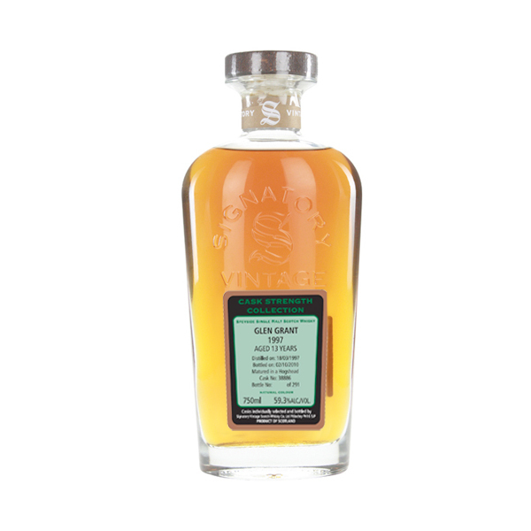

Glen Grant Distillery, built in 1840 by brothers, John and James Grant, is located in the heart of Speyside. The distillery is now the world’s second-largest single malt whiskey brand.

# TASTE NOTES

**COLOR**: Light amber

**NOSE**: White grapes, a fresh apple tart and ripe pears

**TASTE**: Similar to the nose, with hints of vanilla, oak and white pepper.

**FINISH**: Medium, white pepper spice

C:\STOCKLAYOUTS\CURRENT PROJECTS\FN99807-PL\FN99807-IMG05.emf

Imported by Total Beverage Solution

www.SignatoryScotch.com

www.SignatoryScotch.com

IMPORTED BY TOTAL BEVERAGE SOLUTIONS