* 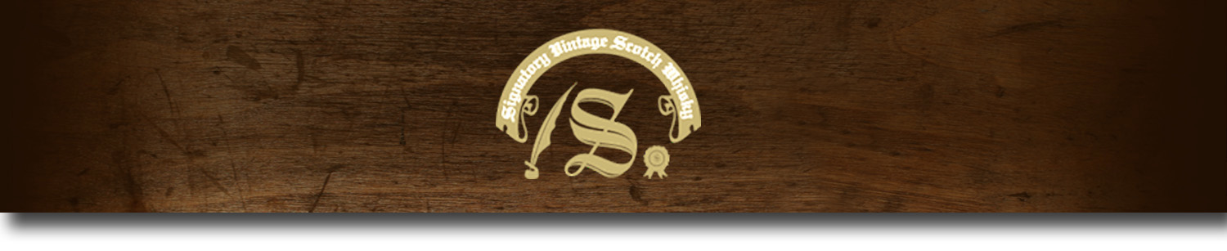Cask Strength Series -

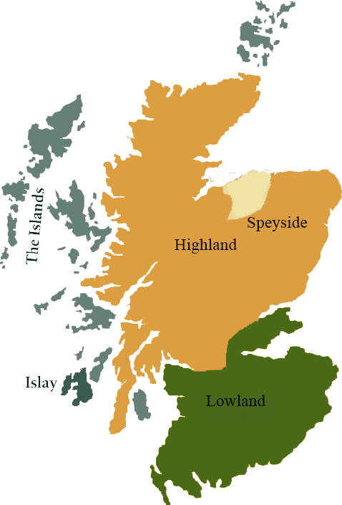*A comprehensive selection of natural strength whiskies, in individually numbered bottles, is available.This selection offers whiskies up to 35 years old, with rare malts being offered in a luxurious gift box with a certificate of authenticity.*

# Craigduff 1973

SPEYSIDE REGION • SHERRY CASK

**AGED:** 33 years

**DISTILLED ON:** April 1973

**BOTTLE ON:** August 2006

**MATURED IN:** Sherry

**CASK NO:** 2515

**BOTTLE NO:** of 371

_________________________________________

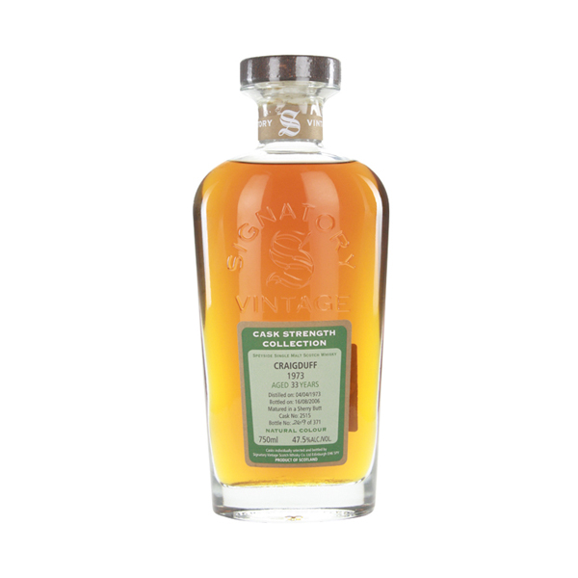

Founded in 1957, Glen Keith Distillery produces, among other single malts, the Craigduff, an experimental peated malt. With its charming pagoda atop the roof of the 3.5 million liter capacity distillery, Glen Keith Distillery sits in the beautiful village of Keith. Lying in close proximity to Strathisla, a fellow Seamgram owned distillery, Glen Keith draws its waters from the Balloch Hills springs and produces delicate, honeyed single malts.

# TASTE NOTES

**COLOR**: Gold

**NOSE**: Spicy with woody peat and red apples. Creamy acacia honey, ginger and a hint of wood smoke.

**TASTE**: Intriguing and delicious, caramelized apples, heather beeswax and hints of clove.

**FINISH**: Savory smoked barley.

C:\STOCKLAYOUTS\CURRENT PROJECTS\FN99807-PL\FN99807-IMG05.emf

Imported by Total Beverage Solution

www.SignatoryScotch.com

www.SignatoryScotch.com

IMPORTED BY TOTAL BEVERAGE SOLUTIONS