* 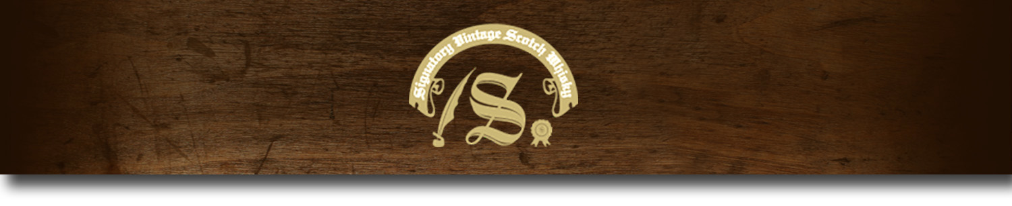86 Proof Series -

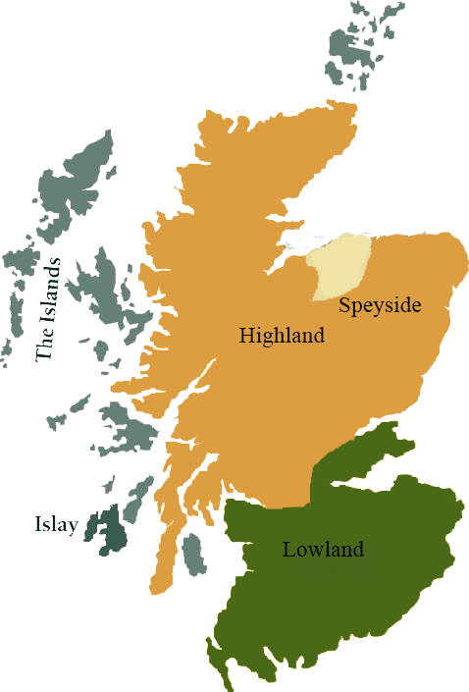*This collection offers a comprehensive range of single malts, up to 20 years old, from each of the distilling areas of Scotland. All bottled at 86 proof, and are offered in color coordinated presentation tins with matching labels, identifying the regions of distillation.*

# Clynelish 1998

HIGHLAND REGION • HOGSHEAD CASK

**AGED:** 15 years

**DISTILLED ON:** March 1998

**BOTTLE ON:** January 2014

**MATURED IN:** Hogshead

**CASK NO:** 7763

**BOTTLE NO:** of 374

_________________________________________

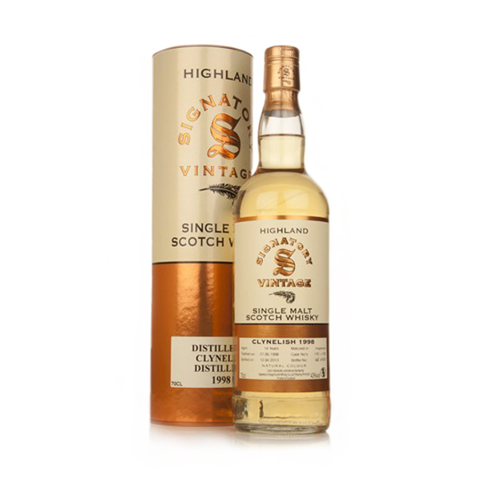

Clynelish Distillery was built in 1967 to replace the old Clynelish Distillery now called the Brora Distillery. The wealthy and controversial 1st Duke of Sutherland built the original distillery in 1819. The new distillery was built just across the road from the original distillery. Being three times lager than before, Clynelish created an exact replica of the stills that were in the original.

# TASTE NOTES

**COLOR**: Gold

**NOSE**: light and waxy sweetness

**TASTE**: flower scented with water. Dried herbs followed by more sweet

**FINISH**: sea salt and dry air with a bitter finish

C:\STOCKLAYOUTS\CURRENT PROJECTS\FN99807-PL\FN99807-IMG05.emf

Imported by Total Beverage Solution

www.SignatoryScotch.com

www.SignatoryScotch.com

IMPORTED BY TOTAL BEVERAGE SOLUTIONS